

MECHATRONICS PROJECT REPORT

**DESIGN OF THE TRANSBOT 1.0**

**Submitted by:**

Dajr Alfred

Ifedayo Olusanya

**Table of Contents**

**INTRODUCTION/ MOTIVATION** **2**

**PROBLEM STATEMENT** **3**

**SOLUTION PROPOSED** **3**

**DEVICE CONSTRUCTION** **4**

DESIGN OF MECHANICAL COMPONENTS 5

1. Transbot Frame 5

2. LCD Housing 7

3. Delivery Mechanism 8

DESIGN OF ELECTRICAL CIRCUIT 9

Custom Interfacing and Power Delivery PCB 9

Schematic Diagram of Interfacing and Power Delivery PCB 11

ELECTRONIC COMPONENTS (THEORY AND JUSTIFICATION) 12

BS2 Schematic Diagram 12

Parallax Serial LCD 13

Pololu Reflectance Sensor 14

Arduino Nano 15

Ultrasonic HC-SR04 Sensor 16

HC-05 Bluetooth Module 17

180 Positional Servo Motor (MG995) 18

Parallax Continuous Rotation Servo Motors 19

SPDT Toggle Switch (Shutdown Mechanism) 20

TRANSBOT ASSEMBLY PROCEDURE 21

**USER INTERFACE & DEVICE OPERATION** **22**

SAFE OPERATION OF DEVICE 22

LCD-BASED USER INTERFACE 22

MOBILE-APP-BASED USER INTERFACE (TRANSBOT_UI) 24

**COMPONENT CLASSIFICATION** **27**

**DEVICE MANUFACTURABILITY** **28**

BILL OF MATERIALS 28

COST ANALYSIS FOR MASS PRODUCTION 29

ADVANTAGE & DISADVANTAGE OF DESIGN 30

**CONCLUSION** **31**

**REFERENCES** **32**

**APPENDIX** **33**

BASIC STAMP 2 CODE 33

ARDUINO CODE 50

LINK TO DEMO VIDEO 54

# INTRODUCTION/ MOTIVATION

Since the introduction of the Ford Model T in 1908, advancements in transportation over many decades have coincided with tremendous improvements to the standard of living in human civilization. Self-driving/autonomous vehicles are on the cusp of being realized and their application in rendering humanitarian aid shall be essential. Vaccines and medical supplies could be delivered to hard hit areas during a pandemic without risking the spread of disease via the logistical chain. Food and water could be delivered to survivors of natural/ man-made disasters when volunteers are in limited supply. Our device, the Transbot 1.0, aims to simulate the operation of such an autonomous vehicle. The Transbot 1.0 is envisioned to do the following;

* To be a dispatch device to provide essential products to people living in areas affected by insurgency.
* To support delivery networks and preserve life by reducing the need for human contact therefore reducing spread of disease during a pandemic.

# PROBLEM STATEMENT

The reliance on human beings for the delivery of medicinal and other essential supplies during pandemics and immediately following natural and man-made disasters leads to increased spread of disease and logistical delays when first responders become overwhelmed.

# SOLUTION PROPOSED

Here we develop a robot that can be controlled remotely and functions mainly to deliver essential packages to set locations. Hence, the spread of communicable diseases is hindered and supply-chain bottlenecks are avoided. The Transbot 1.0 operates in manual (RC) and autonomous modes. It interfaces with a mobile-application-based user interface and can be sent to specific locations to deliver packages. The transbot contains a Pololu QTR-8RC Reflectance sensor that enables it to remain centered as it follows the track during autonomous operation. It also contains a Bluetooth module that enables it to interface with the Transbot_UI application through serial UART communication during manual/ RC mode.

# DEVICE CONSTRUCTION

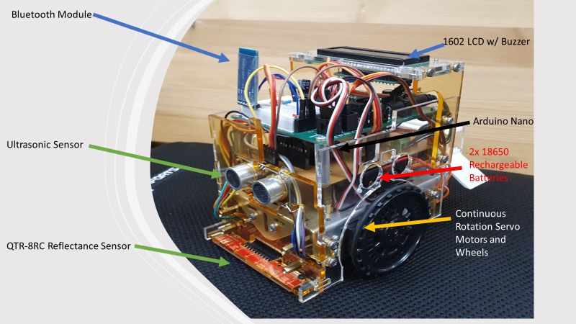

The figure above depicts a front-orthogonal view of the fully assembled Transbot 1.0 with relevant components labeled. The device is built using the Parallax Boebot Chassis as the foundation. An acrylic frame was designed to house the required sensors and actuators with special care taken to ensure optimal device placement.

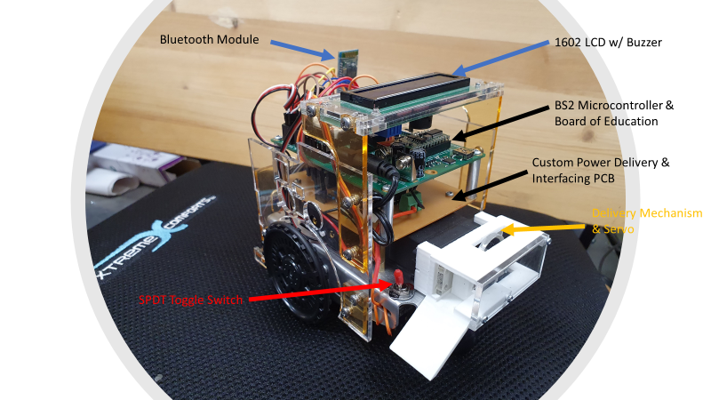

The rear-orthogonal view of the Transbot is depicted in the figure above with relevant components labeled. The master kill switch for instantaneous shutdown, custom delivery mechanism, and custom PCB is visible from this angle. The individual components of the Transbot will be analyzed in the subsequent section.

## DESIGN OF MECHANICAL COMPONENTS

There were three main mechanical components of the Transbot which had to be designed and fabricated. These are the acrylic frame, delivery mechanism, and LCD housing of the Transbot.

### Transbot Frame

<https://docs.google.com/document/d/1DtE0OZCVfYEwcWOtKBIVQAk4WQa4Q8kK7LJY2b4KVQ4/edit>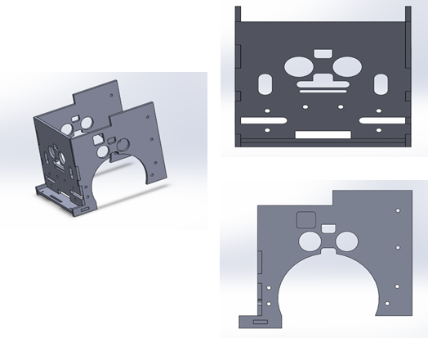

The 3D rendering of the Transbot frame is depicted above. The manufacturability of the frame was the driving factor in its design. The frame was produced by laser cutting several parts from a 1/8th inch thick acrylic sheet. The frame could have alternatively been produced via 3D printing but ultimately laser cutting was selected as the fabrication method of choice. 3D printing allows for more complex shapes but this comes at the cost of quite a relatively lengthy printing time and less accurate dimensions when compared to laser cutting. Also, the PLA 3D printing filament available was opaque while the acrylic used for laser cutting was translucent/ transparent and more aesthetically pleasing.

Noticeable features of the frame design are slots for mounting ultrasonic sensors, a gap on the left panel to allow for the programming of the Arduino microcontroller, a mounting slot for the reflectance sensor, mounting points for the LCD housing, and a myriad of holes for fastening the frame to the Boe Bot chassis. The fully constructed frame is depicted in the images below. The frame panels were designed meticulously to allow them to fit perfectly into place with no interference with the chassis or other panels and components. Spacers were also added between the side panels and chassis to allow some clearance in the event that left and right ultrasonic sensors were used. Although these lateral ultrasonic sensors were included in the initial design, they were later removed after the fabrication of the frame was completed. The Transbot frame was designed using SolidWorks. M3 screws and nuts were used to attach the frame to the Boe Bot Chassis while edge cuts were used to fit the frame panels together.

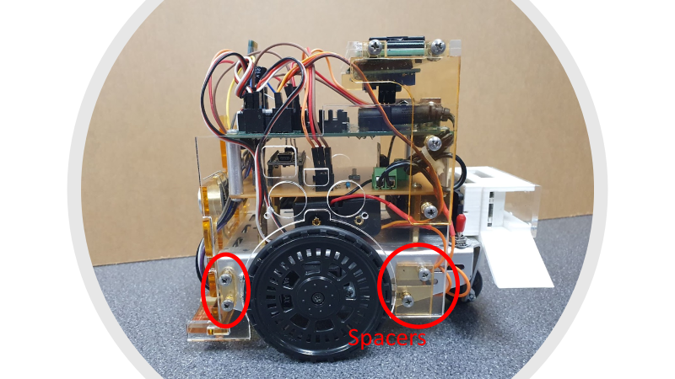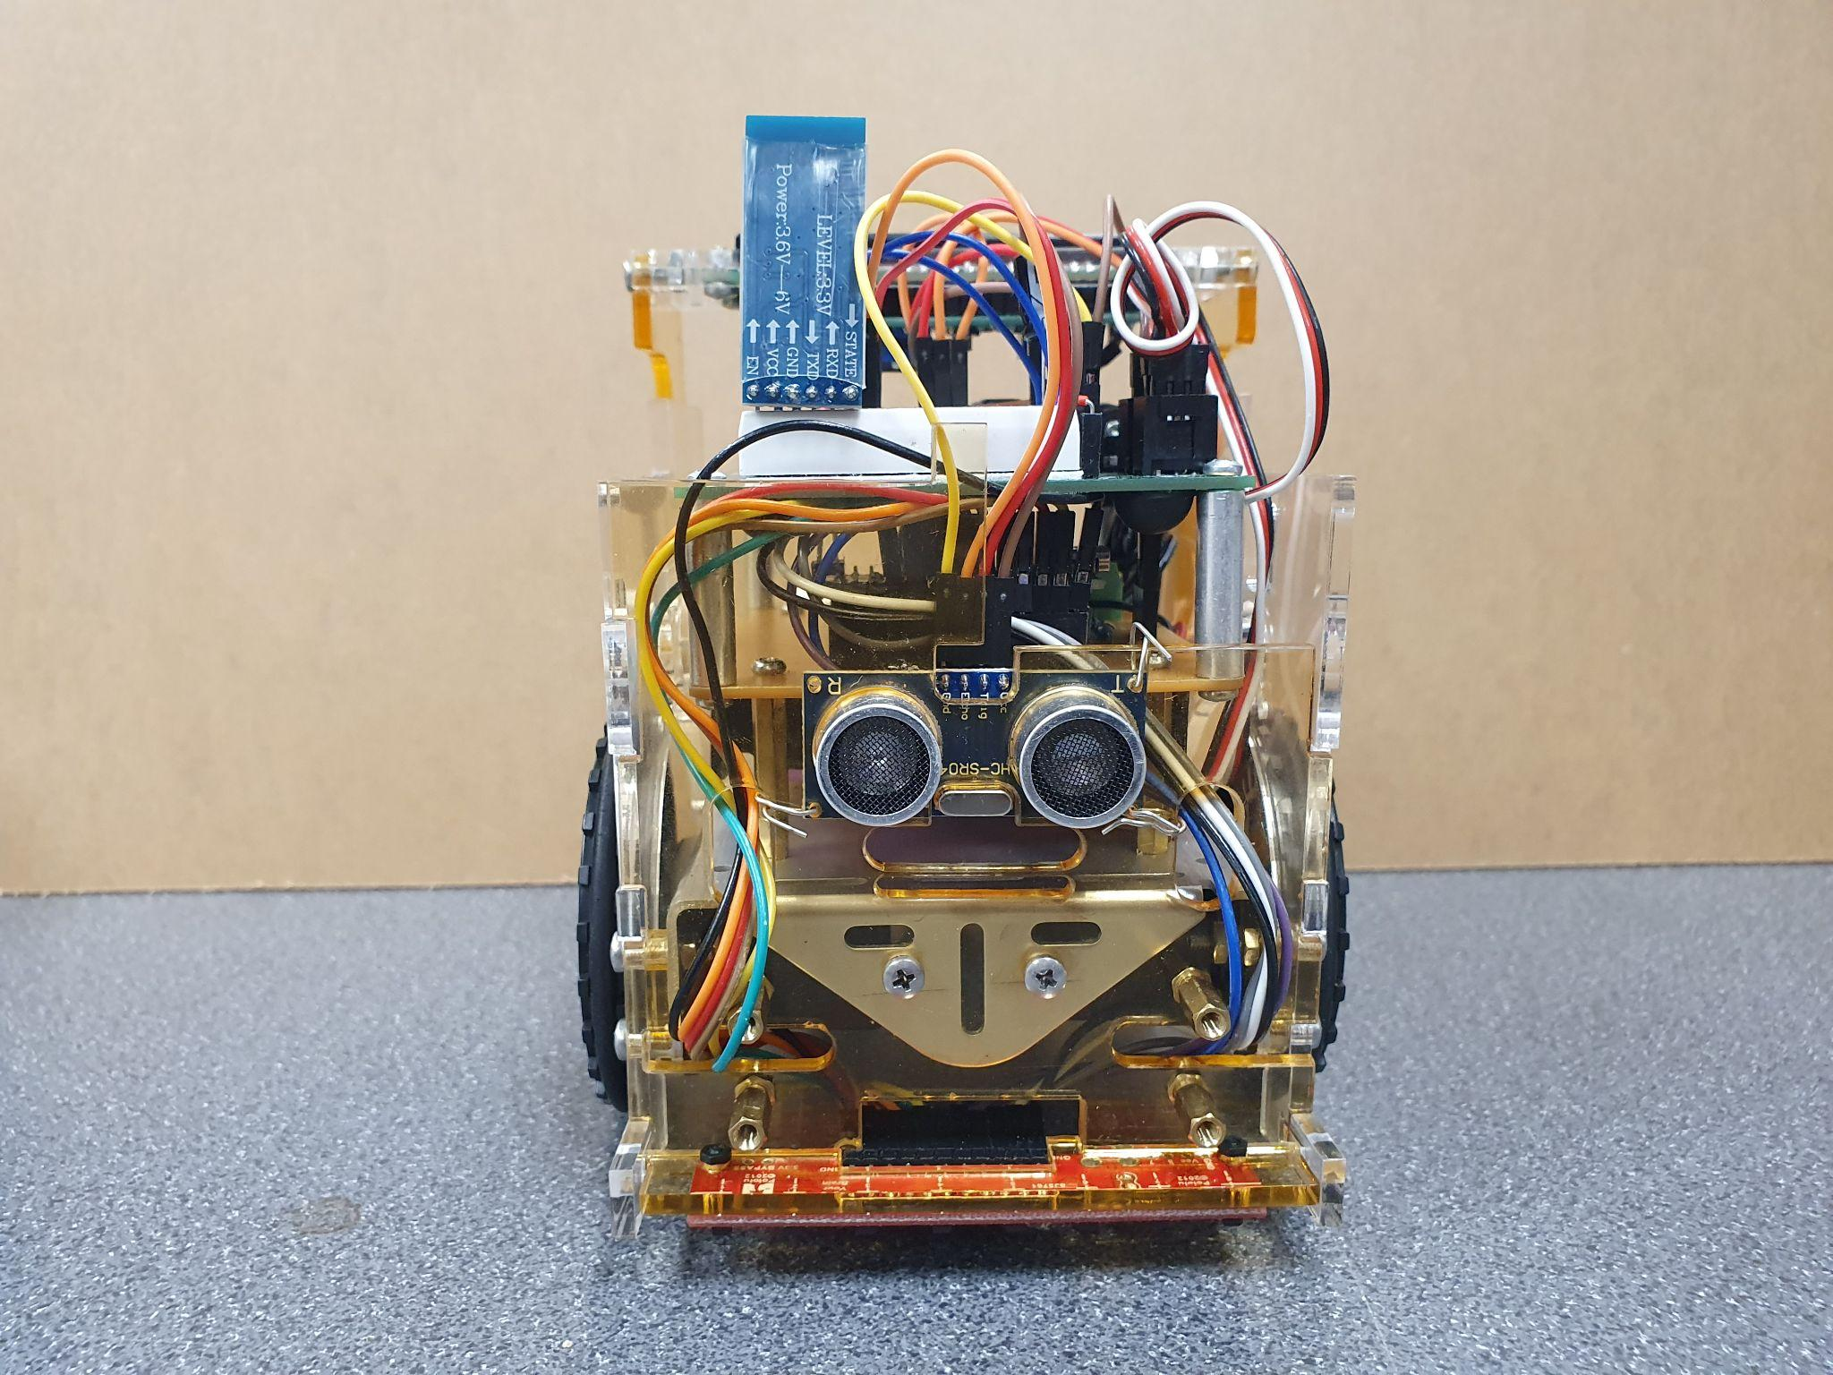

# 

### LCD Housing

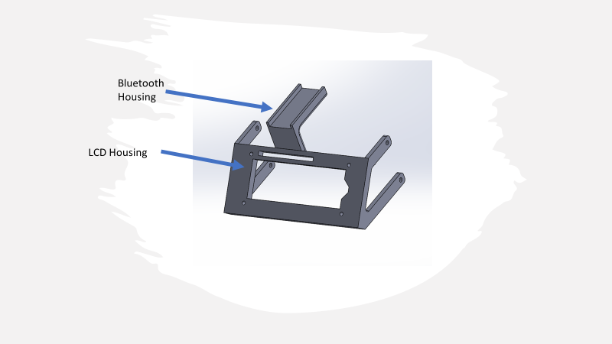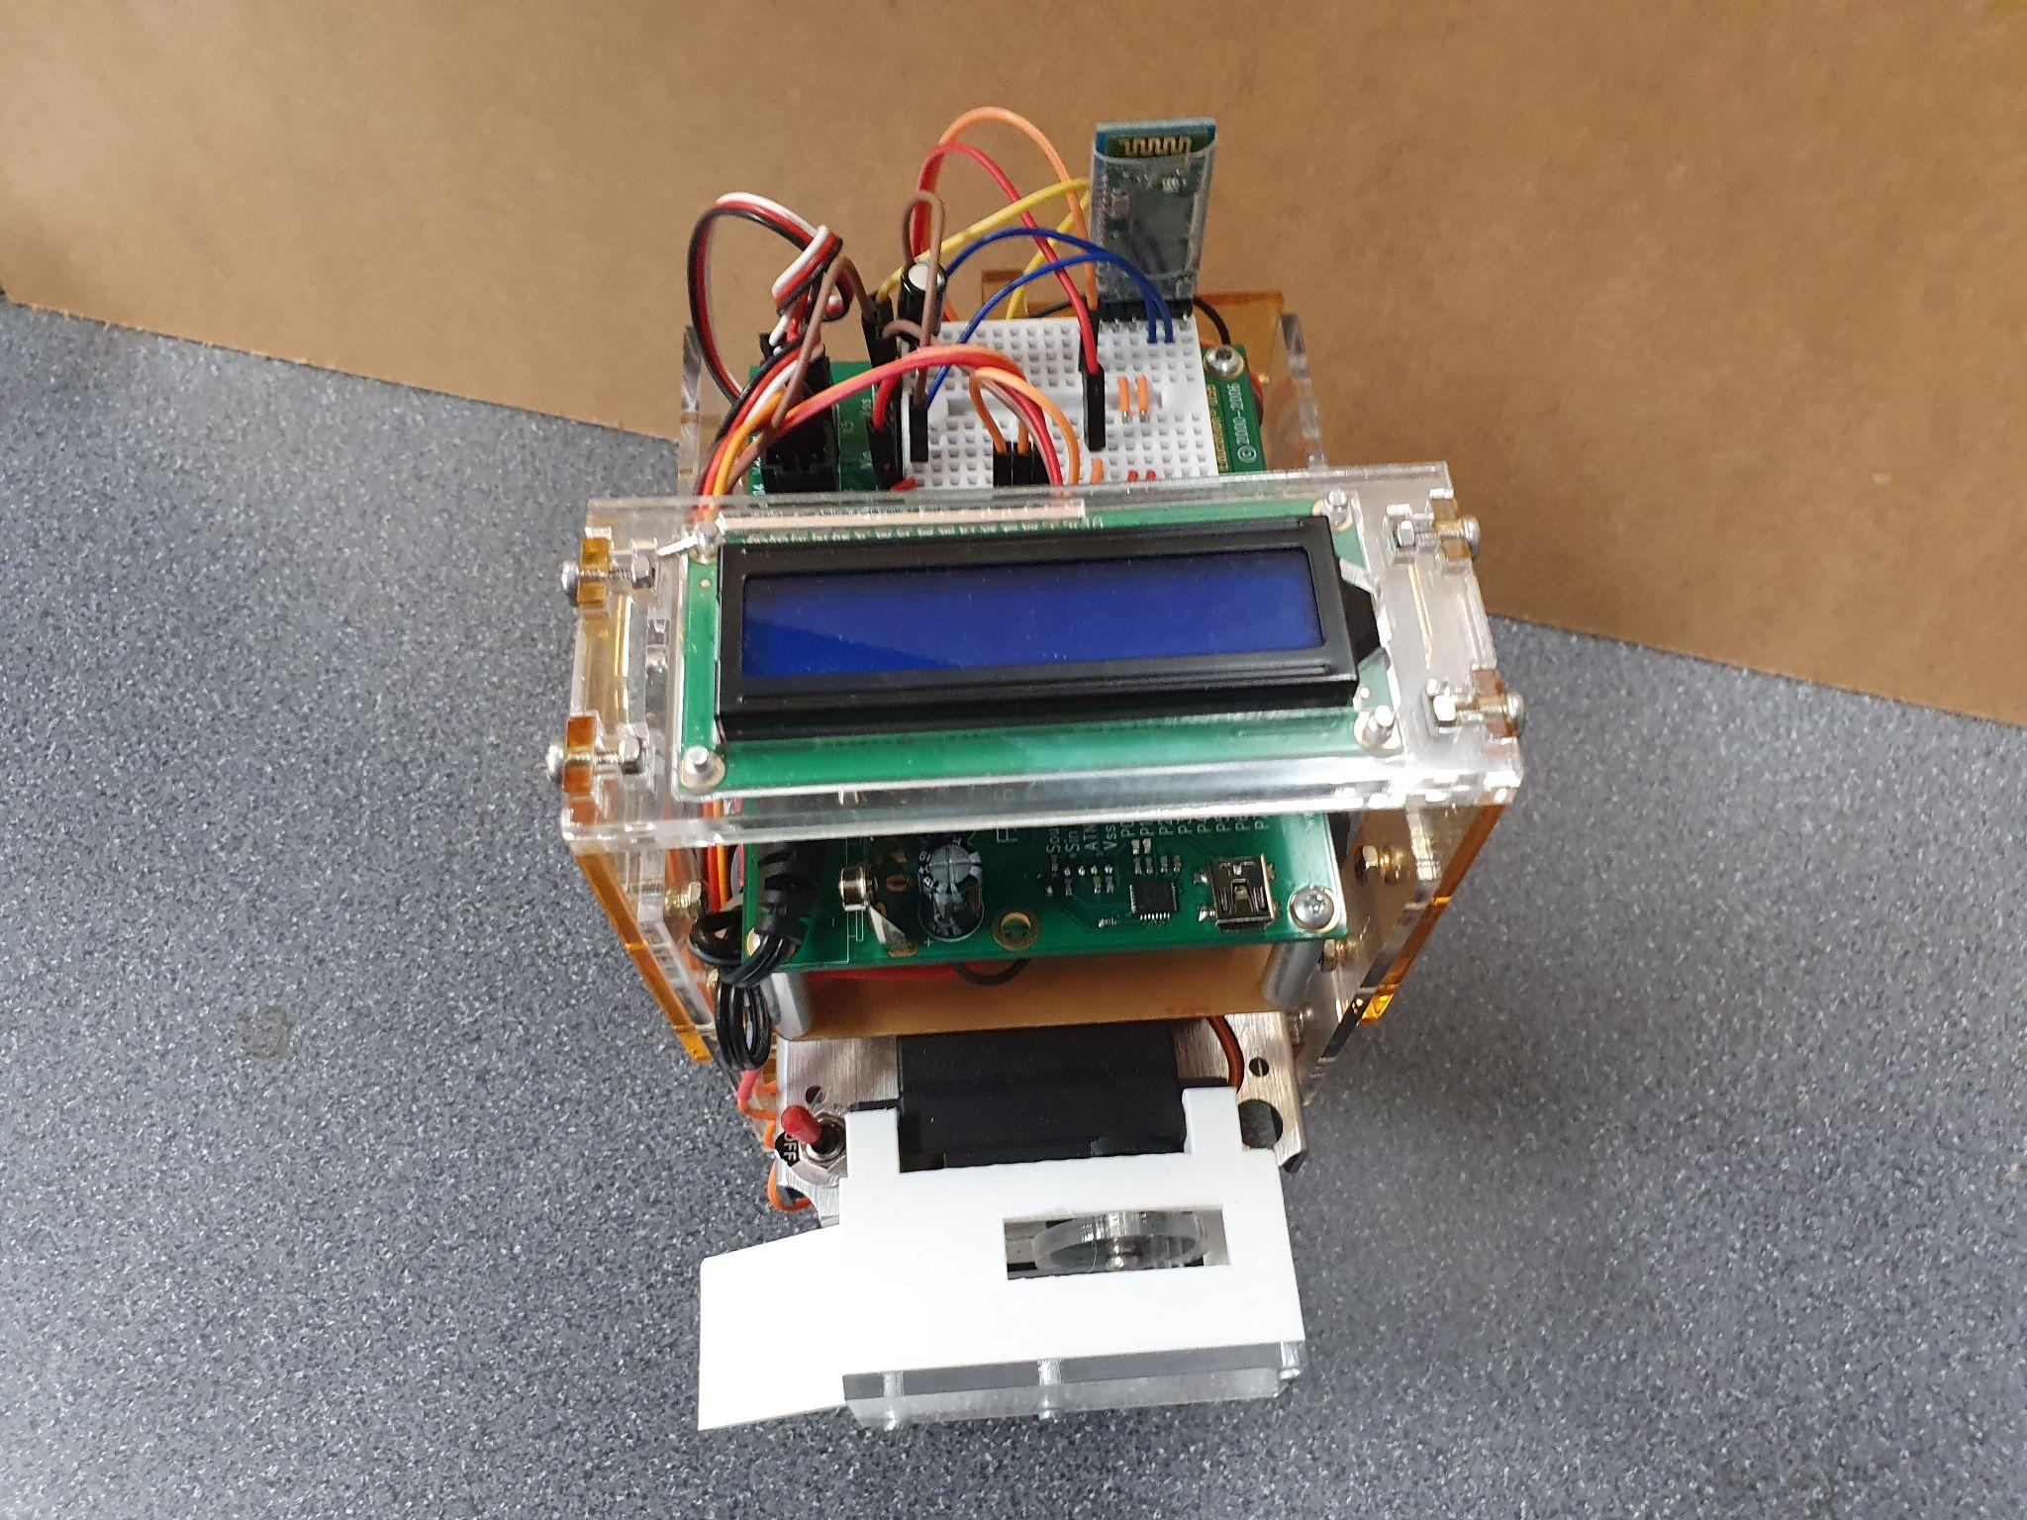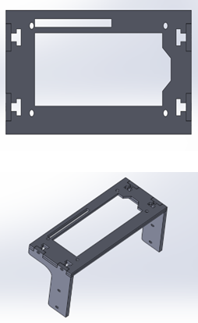

Depicted in the images above is the LCD housing. The first figure shows the original 3D-printed design of the housing. This design was intended to be rear-mounted with the screen angled upwards towards the user. This design also featured a horizontal platform upon which the BT module was intended to be mounted. This design was ultimately abandoned due to its position obscuring the Board of Education’s USB port and the fact that it would interfere with the positioning of the delivery mechanism. The assembled redesigned housing is pictured in the second figure with its 3D rendering being displayed in the remaining figures. The BT module has also been moved to the breadboard of the BS2 in the final design. The LCD housing was designed using Solidworks. M3 nuts and machine screws and edge cuts were used to assemble the LCD housing.

### Delivery Mechanism

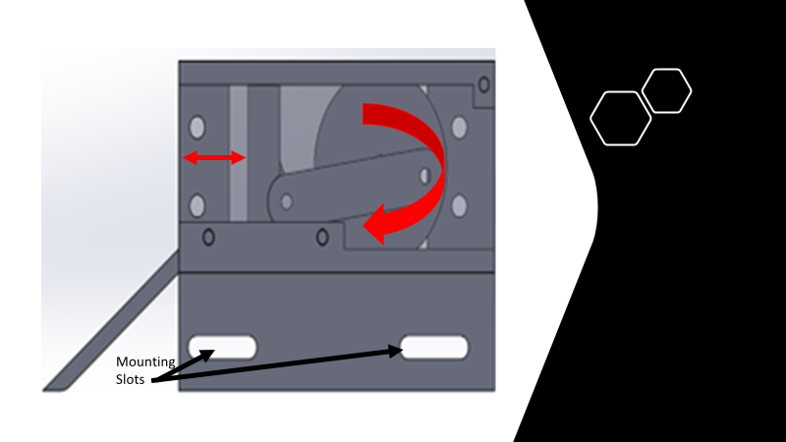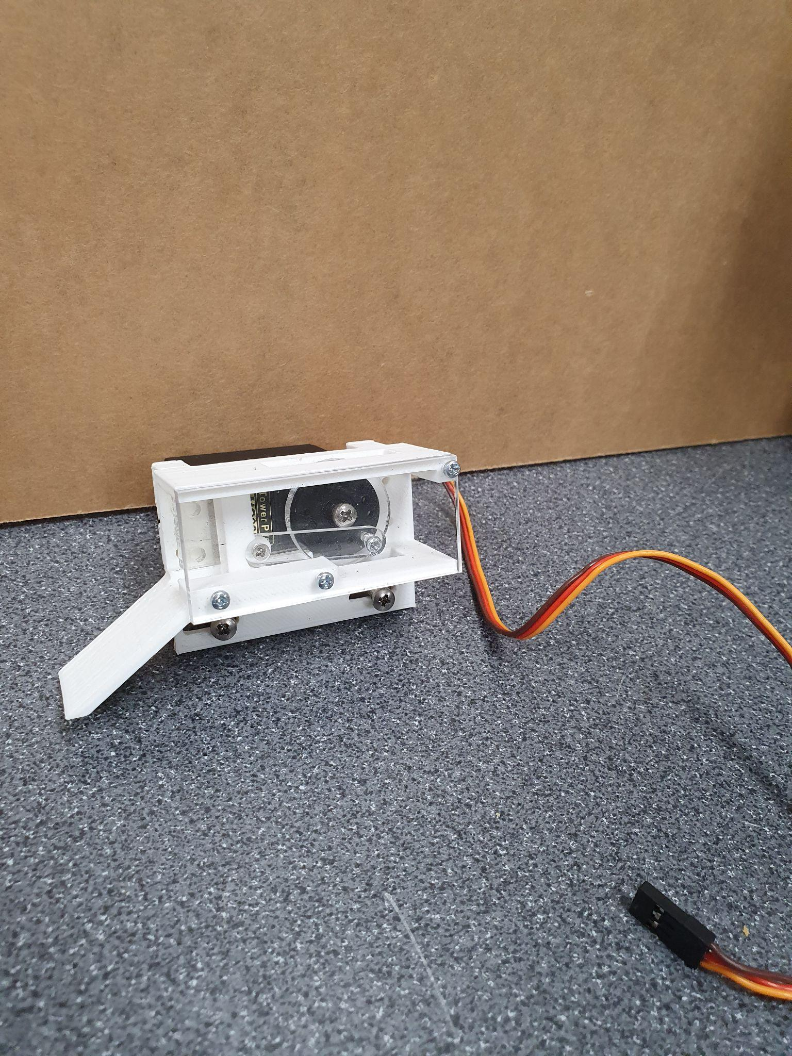

Depicted above is the delivery mechanism of the Transbot. The first figure shows the 3D rendering of the mechanism. As the flywheel attached to the positional servo motor rotates, translational motion is induced in the plunger and it moves in/ out depending on the direction of rotation. The second figure depicts the assembled mechanism. It should be noted that the central screw of the flywheel acts as the limit for the retraction of the plunger and was used to determine the servo input required to set the mechanism to the loading position. The main structure and plunger of the mechanism were 3D-printed using white PLA while the flywheel attachment and arm were laser cut from acrylic. A transparent covering of the mechanism was included for increased aesthetic appeal and to ensure proper device operation. Initial designs of the mechanism were created using Autodesk Inventor while adjustments and final design modifications were made in SolidWorks. M2 and M3 screws were used to assemble the delivery mechanism.

## DESIGN OF ELECTRICAL CIRCUIT

### Custom Interfacing and Power Delivery PCB

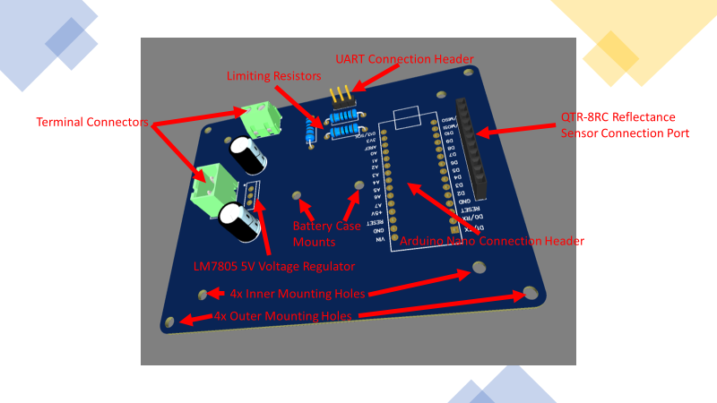 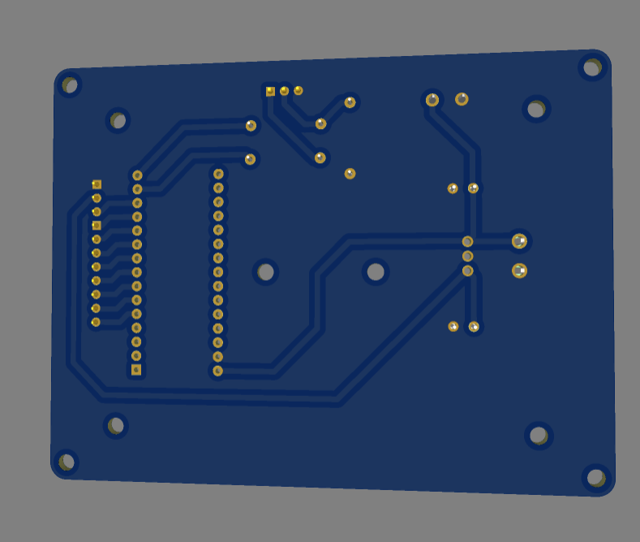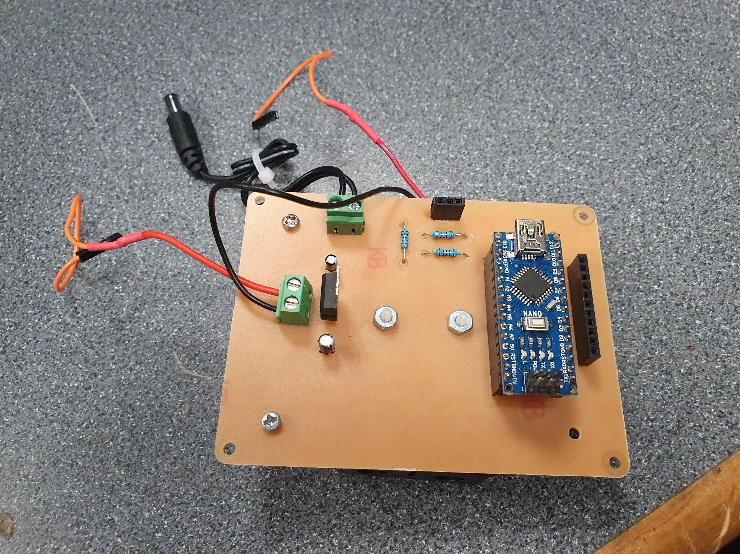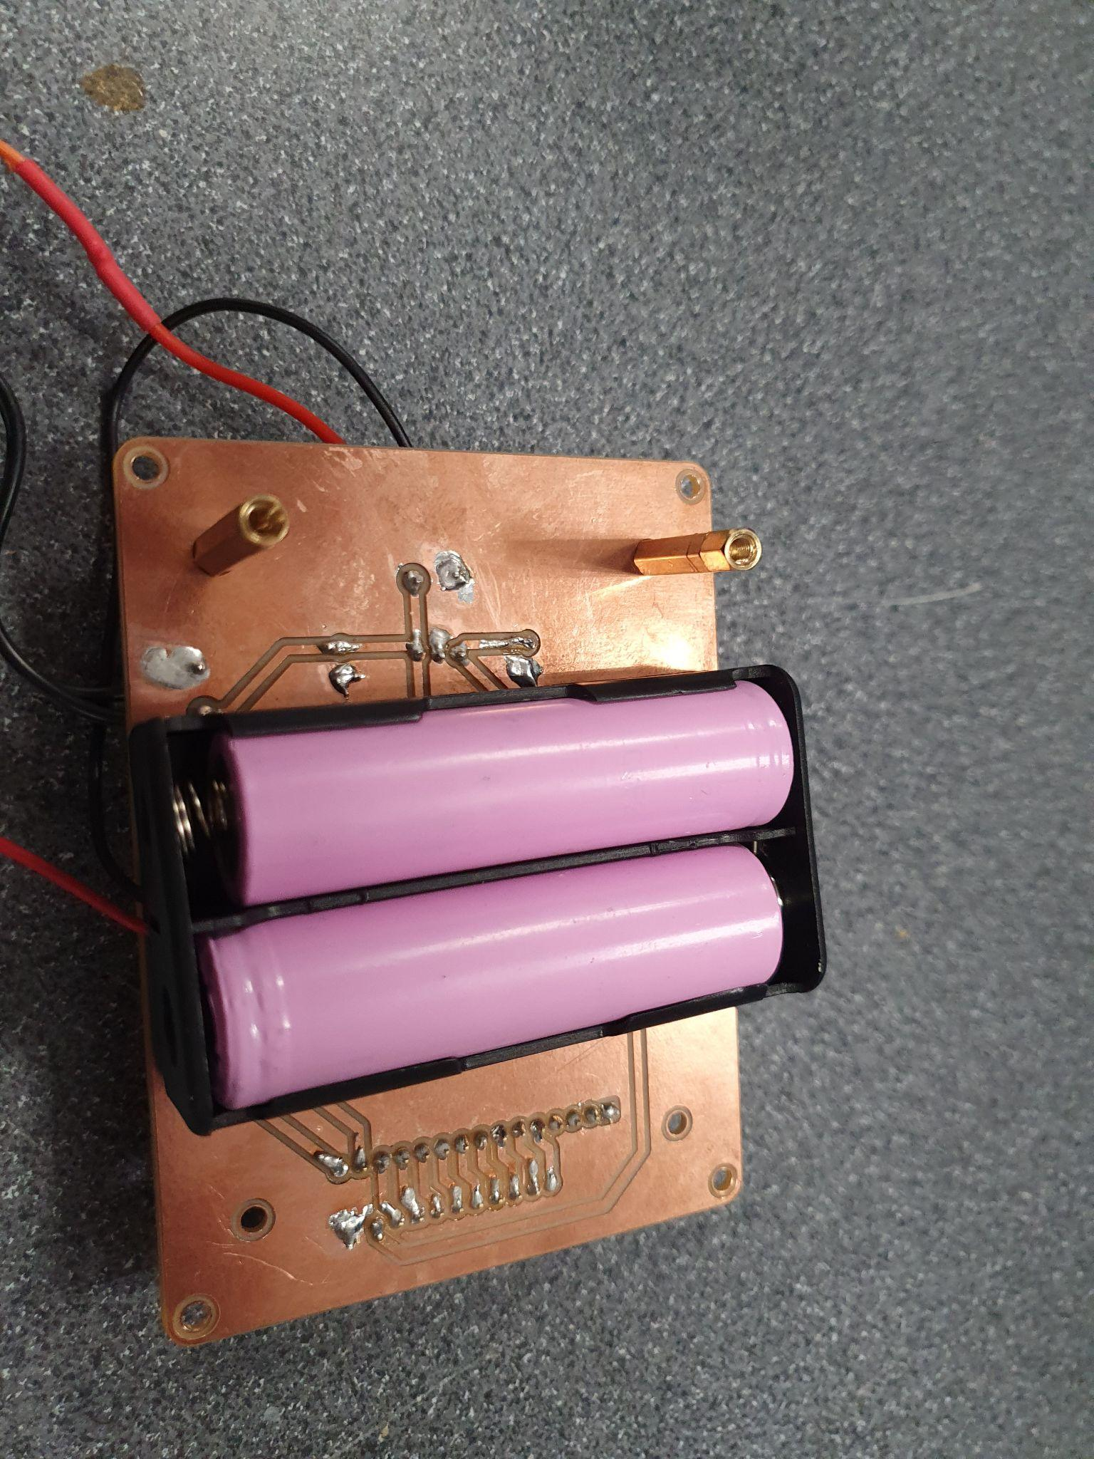

Depicted above is the delivery mechanism of the Transbot. The first figure Depicted above is the custom interfacing and power delivery printed circuit board (PCB) incorporated into the Transbot. All relevant PCB components are labeled on the 3D rendering of the PCB in the first figure. The bottom-side 3D rendering of the PCB is depicted in the second figure. The remaining figures showcase the fully assembled PCB. The PCB Schematic capture and PCB layout were completed using easyEDA. A single-sided (4”x5”x1.6mm) FR-1 PCB Blank was used to mill the PCB using Bantam Tools software and Othermill CNC machine. It was necessary to incorporate a custom-printed circuit board into the Transbot for several reasons. Firstly, the BS2 only has 16 GPIO pins while the reflectance sensor would require 9 of them. This would leave only 7 available. When the servo motors, ultrasonic sensor(s), Bluetooth module, and LCD are all taken into account, there would not be any free BS2 pins available. To reduce the number of GPIO pins required for interfacing with the reflectance sensor, an Arduino Nano microcontroller was utilized as an interfacing IC. The Arduino reduces the 9 GPIO pin requirement to 2 pins for UART Serial communication. Limit resistors on the PCB make this UART connection 3.3V compatible. The Arduino also possesses a library for interfacing with this specific sensor and this allows for easy calibration and reduces the computational burden of the BS2. The custom PCB comes equipped with 3 sets of mounting holes. The innermost pair is for mounting the 18650 battery case to the bottom of the PCB. These batteries are rechargeable, have a nominal voltage of 3.7V, are higher in energy capacity than AA batteries, and deliver a high instantaneous power output. This allows for the use of 2 rechargeable batteries to power the Transbot in place of 4 AA batteries. The custom PCB also features a linearly-regulated 5V output which is used to power the reflectance sensor. Screw terminals on the PCB allow for the connection of power inputs from the battery pack and kill switch as well as power output via DC-Jack to the Board of Education (BoE). The middle 4 mounting holes are used to mount the PCB to the chassis and the outer 4 mounting holes are used to mount the BoE above the custom PCB. The schematic of the custom PCB is below.

### Schematic Diagram of Interfacing and Power Delivery PCB

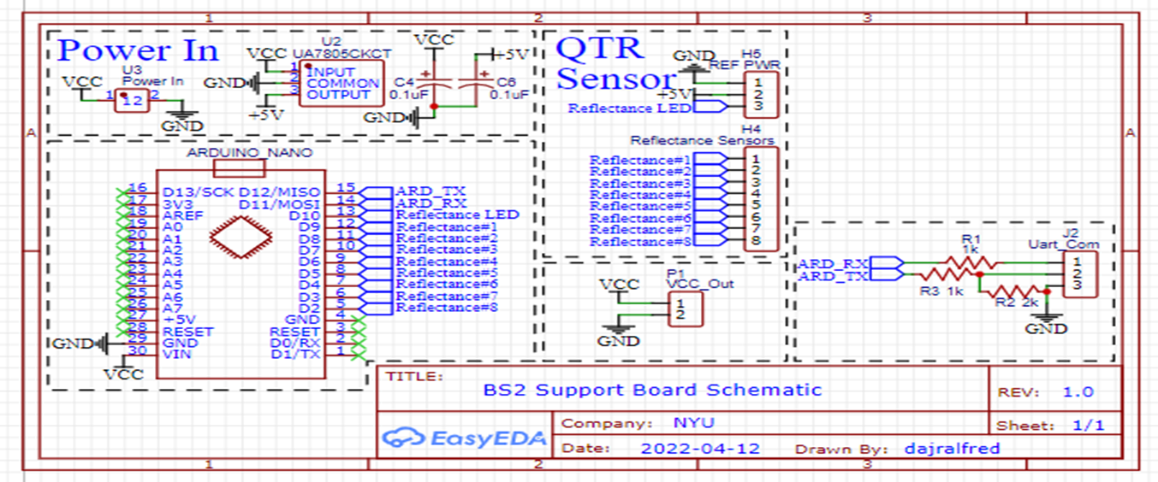

## ELECTRONIC COMPONENTS *(THEORY AND JUSTIFICATION)*

### BS2 Schematic Diagram

## 

The figure above depicts the schematic diagram of the Transbot. All the relevant electronic components of the Transbot and their respective connections are shown. The ultrasonic sensor was chosen The operation of these components will be explained in the subsequent section.

### Parallax Serial LCD

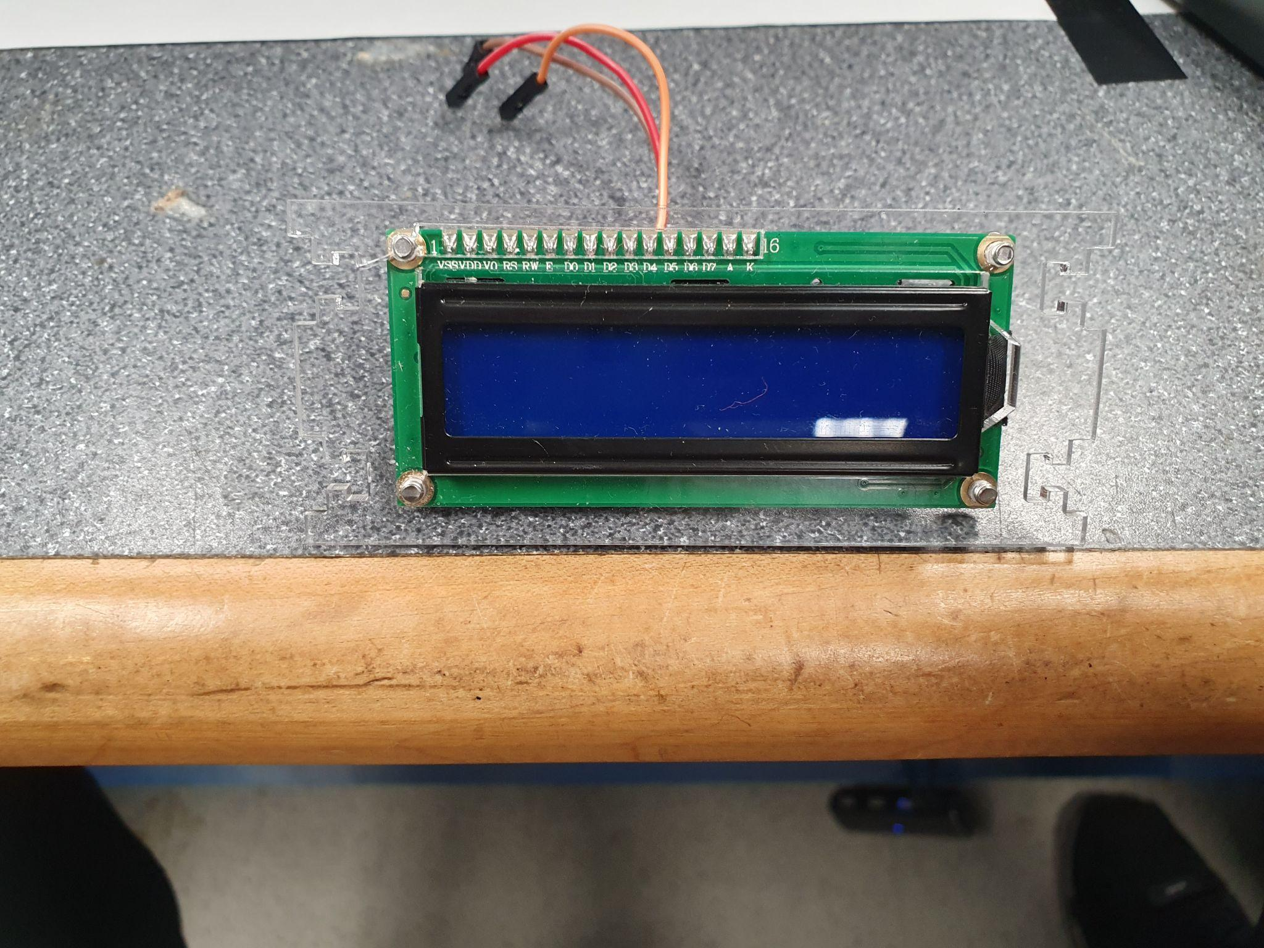

The Parallax 2×16 Serial LCD has two sixteen-character-wide rows for displaying messages. The display is controlled by serial messages from the BASIC Stamp 2. The BASIC Stamp 2 sends these messages from a single I/O pin connected to the LCD's RX serial input. The Parallax Serial LCD has a self-test mode to make sure it's in working order and that the contrast is properly set. There are two switches labeled (SW1 and SW2) on the back of the LCD module, for self-test mode and baud rate adjustment. The LCD module also has a built-in buzzer which could be commanded to play a range of notes for adjustable durations of time. The LCD is used as an onboard user interface to monitor Transbot operation.

## 

### Pololu Reflectance Sensor

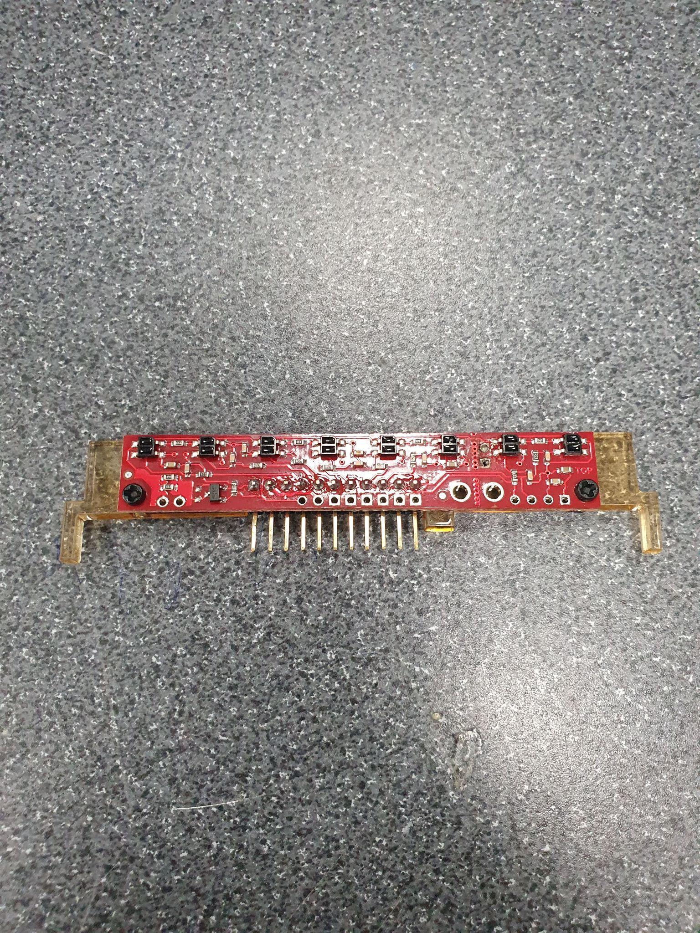

The Pololu QTR-8RC reflectance sensor module contains 8 infrared ray LEDs and phototransistors installed on a 0.375" deck, which allows for accurate line detection and following for robots. In its installation, each LED pair is arranged in series to reduce current consumption by half; it also contains a MOSFET transistor that enables added sensing and power savings by allowing LEDs to be turned off. The Pololu serves mainly as a line sensor, it could also serve as a general-purpose proximity sensor. On the Transbot assembly, the Pololu sensor is connected directly to the Arduino and sends position readings of the track to the Arduino. These position readings are communicated to the BS2 via serial UART communication between the Arduino and BS2.

### Arduino Nano

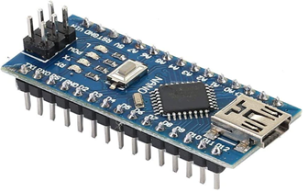

The Arduino Nano is one of the smallest Arduino microcontrollers available on the market today. It is a relatively cheap but powerful microcontroller with library compatibility with most sensors available. Arduino has a large community with open-source codes available which gives room for reduced roadblocks while coding. On the Transbot, the Arduino serves primarily as an interfacing device between the BS2 and the Pololu reflectance sensor. The Arduino was programmed to calibrate the Pololu and collect position readings and send these position readings to the BS2 once called upon by the BS2.

## 

### Ultrasonic HC-SR04 Sensor

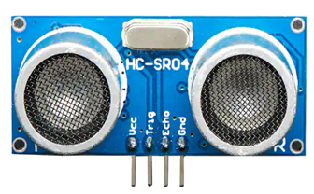

The ultrasonic sensor operates by sending out an ultrasonic wave that is much higher than the range of human hearing and then producing an output pulse that is timed to the length of time it takes for the echo of the burst to return to the sensor. The target distance can readily be estimated by measuring the echo pulse width. In the transbot, the HC-SR04 sensor functions mainly to detect the presence of an obstacle and also to start the delivery sequence once the transbot is 8cm away from the delivery location.

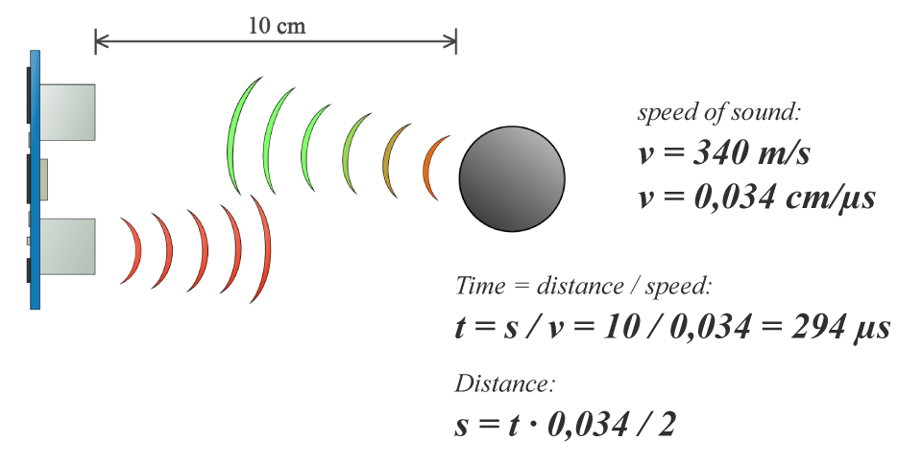

### HC-05 Bluetooth Module

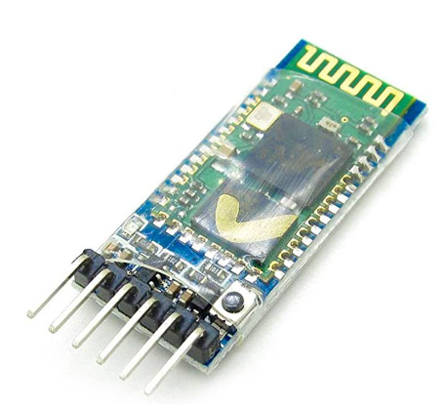

The HC-05 Bluetooth module is a component that enables wireless communication via Bluetooth and relays that information to the Transbot via a UART serial interface. The HC-05 has a default password of 1234, a default baud rate of 9600, and a default name of “HC-05”. The name of the module was reconfigured to “Tranbot”. The baud rate was also adjusted to 2400 to ensure that the BS2 can successfully receive all incoming bytes of data. On the Transbot, the Bluetooth module enables 2-way communication between the Transbot_UI application on the user’s smartphone and the BS2. Firstly a Bluetooth pairing and connection between the phone and BS2 are set up using the password of the HC-05. The HC-05 collects instructions from the application and sends data to the BS2. The BS2 performs a function based on instruction and sends out feedback to the application and LCD. The feedback to the application can be seen on the display on the Transbot_UI screen.

### 180 Positional Servo Motor (MG995)

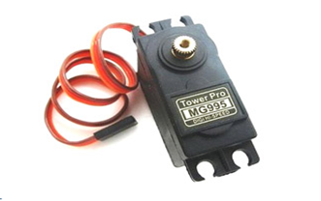

The MG995 used is a 180 degree positional servo motor that enables rotation to specified angular positions. The MG995 used is a part of the mechanical delivery system and it is linked to a connecting rod and flywheel. Rotation of the MG995 enables the conversion of rotational motion into translational motion therefore simulating a plunger system that pushes out packages at delivery location. With the angles of the MG995 motor rotation determined, the maximum possible length of connecting shaft was determined for adequate operation of the delivery system.

### Parallax Continuous Rotation Servo Motors

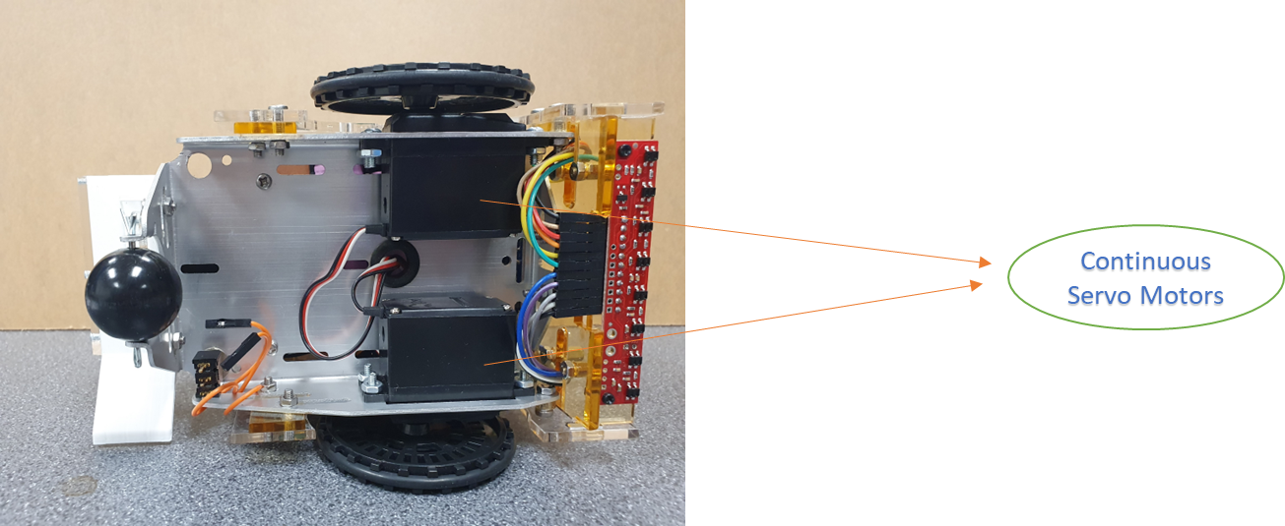

The parallax continuous rotation servo is a bidirectional servo and interfaces easily with the BS2. The continuous rotation servo enables the transbot to turn left, turn right, spin left, spin ring, move forward, and move backward. It gives the transbot mobility and enables motion for easy delivery of items. These servos were used instead of ordinary DC motors for two reasons. Firstly, the chassis has been designed to fit these specific sensors. Secondly, an ordinary DC motor would require an H-bridge or some other driving circuitry.

### SPDT Toggle Switch (Shutdown Mechanism)

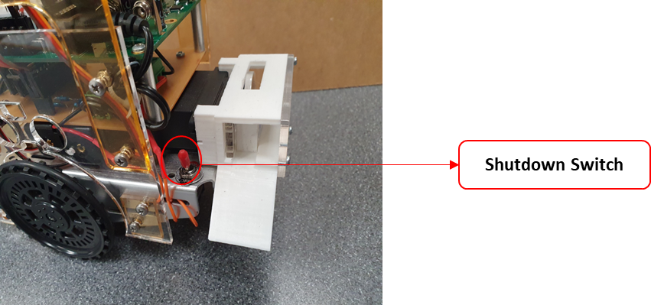

The Single Pole Double Throw master kill switch is connected directly to the power delivery PCB and enables immediate shutdown during malfunctioning and incorrect use of the Transbot 1.0. The common terminal of this switch is connected to the battery **+ terminal.** The **+ terminal** of the power delivery PCB is connected to the Normally Open (NO) terminal of the SPDT switch. In the event of a malfunction, the switch is toggled to the off position and all power to the Transbot is cut off.

## TRANSBOT ASSEMBLY PROCEDURE

1. Attach Master Toggle Kill Switch to Boe Bot Chassis
2. Screw 18650 battery case to bottom of Custom PCB, connect battery - to PCB, **+** to kill switch and load in batteries
3. Attach delivery mechanism to chassis using M3 nuts and screws (keep wire free)
4. Attach assembled Custom Interfacing and Power Delivery PCB to Chassis using M3 standoffs and wire up DC Jack
5. Connect NO terminal of Kill-Switch to **+** input of Custom PCB
6. Attach Continuous Rotation Servos to Chassis and mount wheels to the Servo shafts (Keep wires free!)
7. Attach Ultrasonic sensors to Transbot frame panels as necessary. (left & right ultrasonics may be omitted)
8. Attach QTR reflectance sensor to corresponding lower front frame panel and wire reflectance sensor to custom PCB
9. Mount Board of Education (BoE) above custom PCB using Boe Bot standoffs and connect DC jack and Arduino connections to BoE
10. Connect Servo Motors and Bulk capacitor to BoE
11. Loosely screw left and right frame panels only chassis using spacers and M3 nuts and screws
12. Fit front main frame panel and lower panel into position and secure to frame using M3 screws then tighten side panels
13. Connect ultrasonic sensor(s) and Bluetooth module to BoE

# USER INTERFACE & DEVICE OPERATION

## SAFE OPERATION OF DEVICE

The safe operation of the Transbot begins by placing the Transbot at the home position on the track. **The device should be placed back at this position whenever autonomous mode is engaged**. The device is then turned on by placing the SPDT master toggle switch to the ON position and setting the BoE switch to position 2. The Transbot is quite simple and straightforward to use from then on owing to the quite intuitive user interface. The user interface of the Transbot consists of two components. These are the serial LCD & Buzzer and the android-app-based user interface (Transbot_UI).

## LCD-BASED USER INTERFACE

The LCD & buzzer provide a runtime on-device method of monitoring the operation of the Transbot. During device operation, various messages are displayed based on the event currently occurring. The LCD’s built-in buzzer is also used to indicate the occurrence of different events.

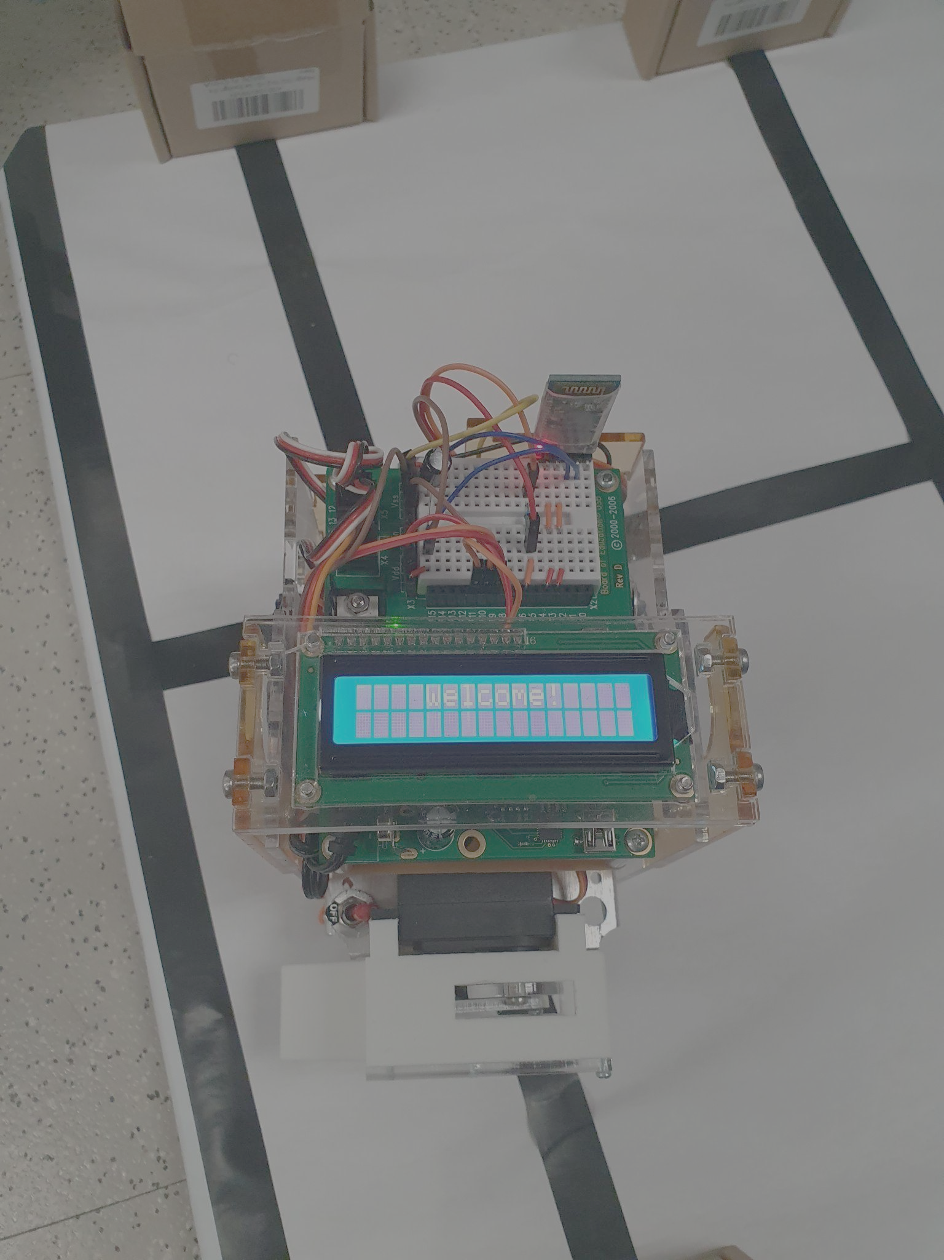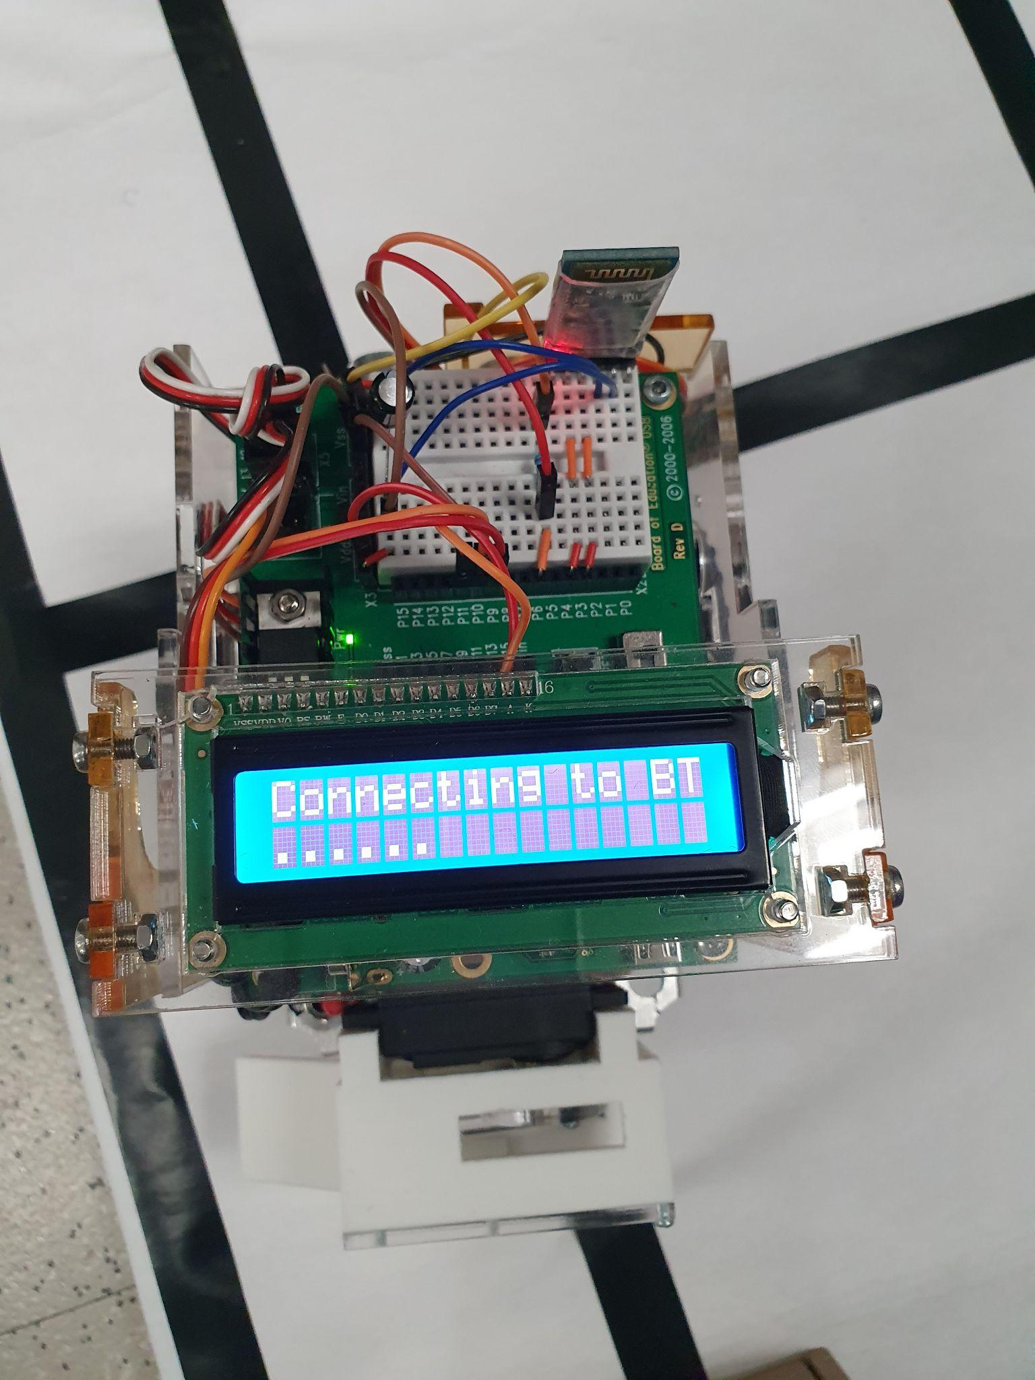

On device start-up, the buzzer sounds and a welcome screen is displayed. This screen is depicted in the first figure above. The Transbot then awaits an incoming start signal from the Transbot UI on the mobile App and displays the image shown in the second image above.

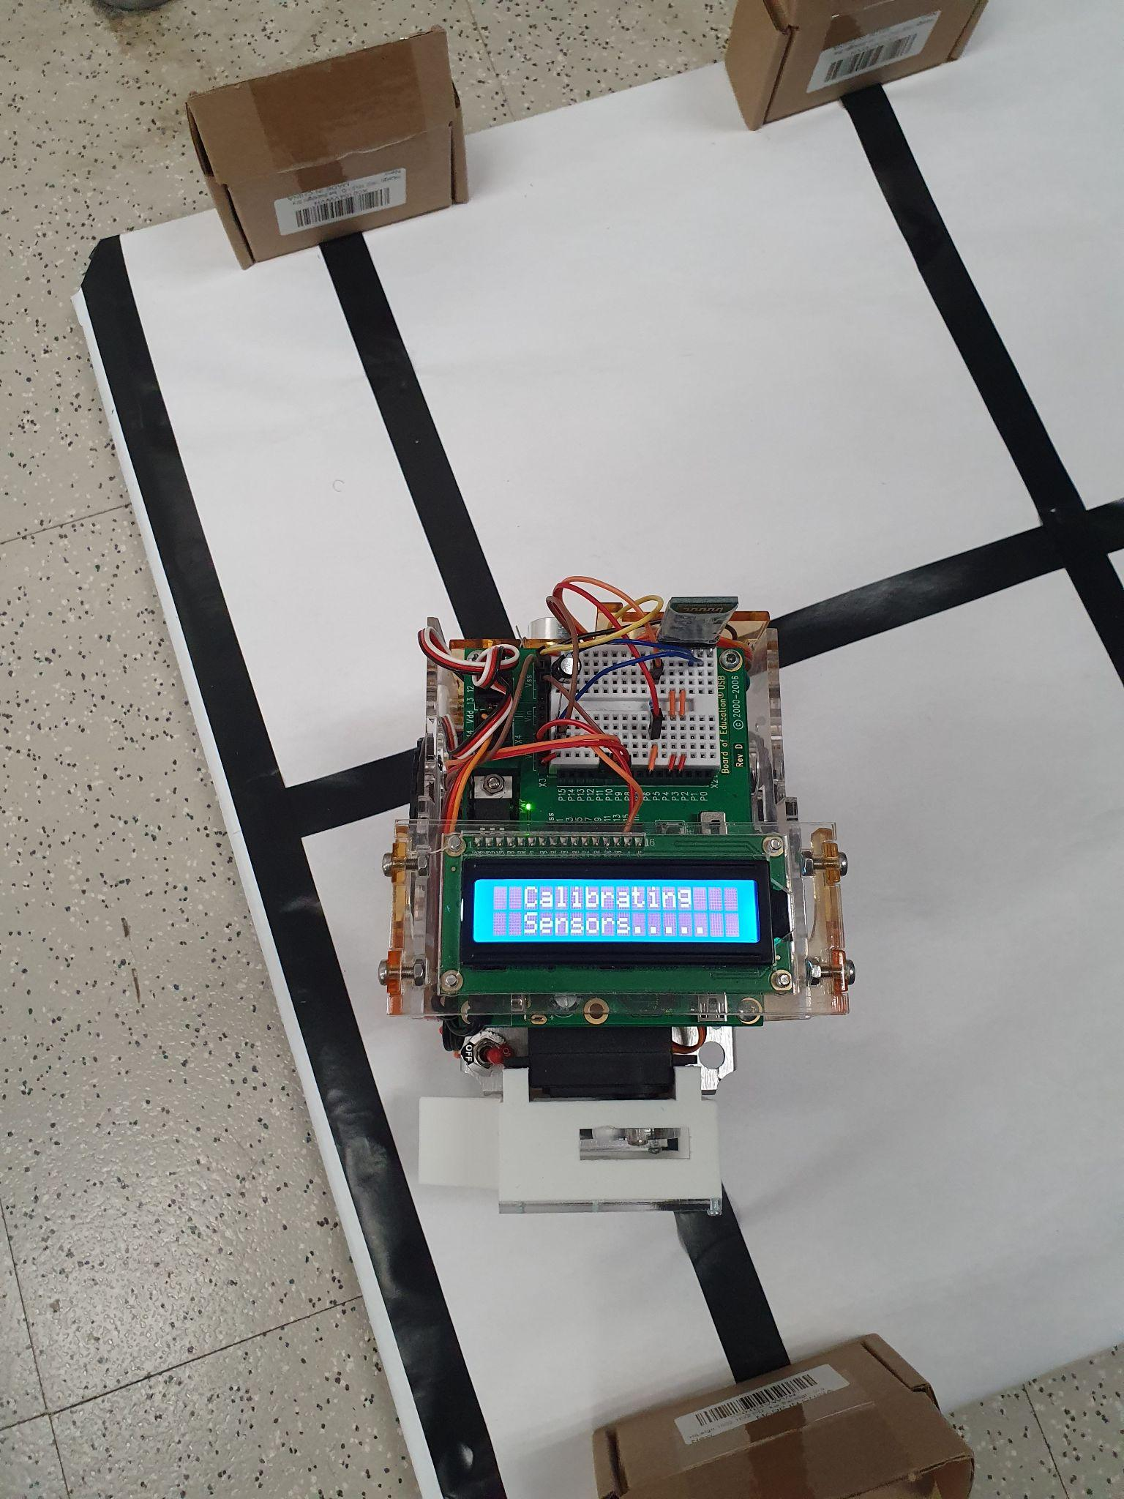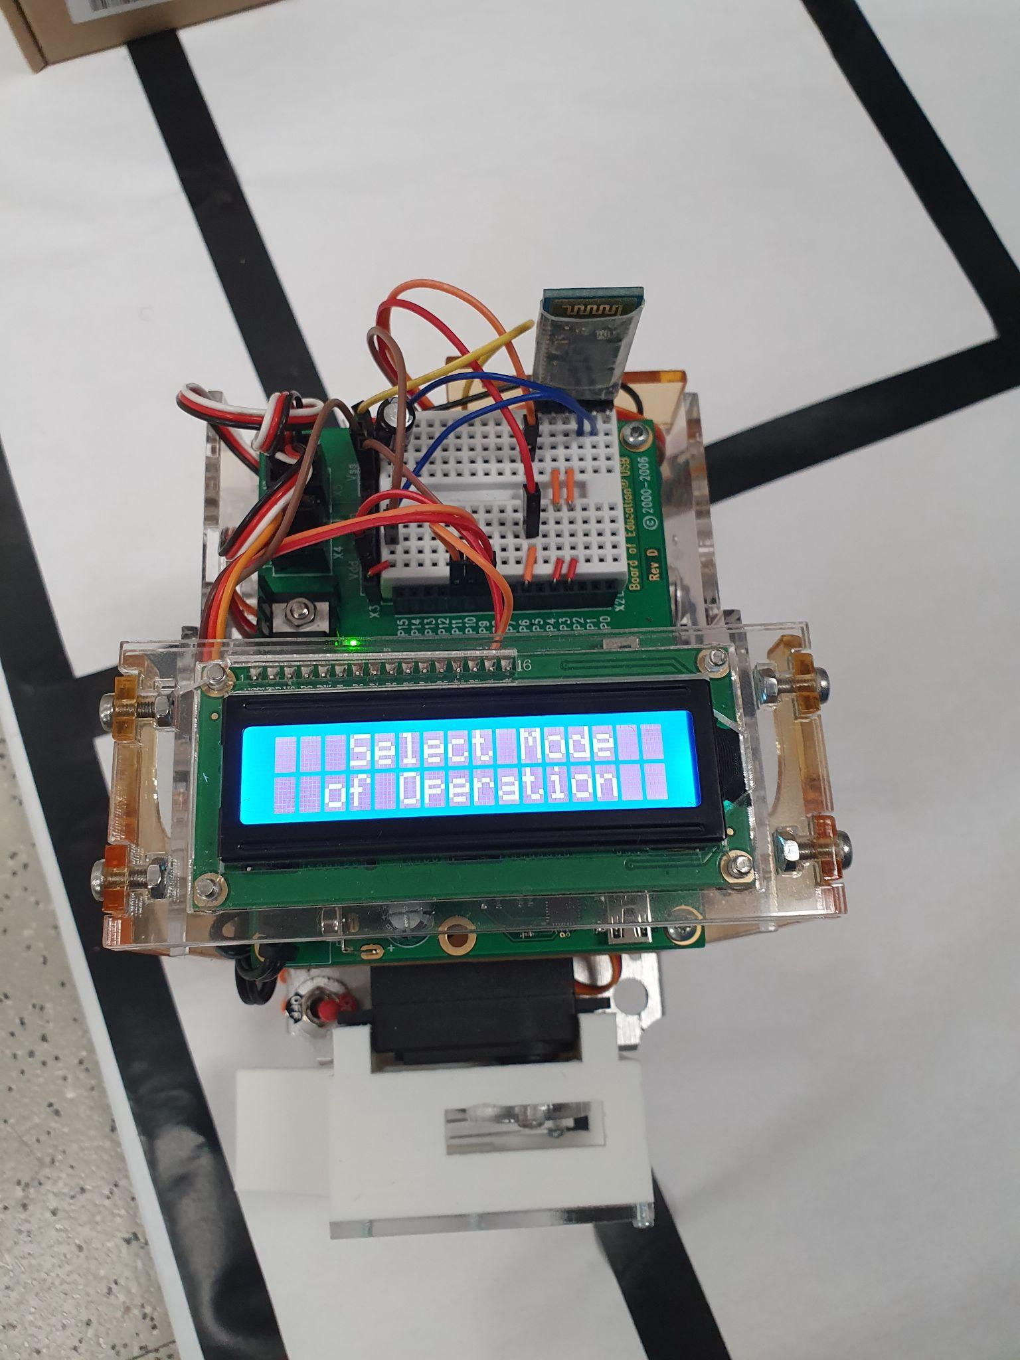When the start signal is received, the calibration of the reflectance sensor begins and the message shown in the first figure above is displayed. Once calibration is complete, the Transbot awaits the selection of the operating mode from the app UI and the message in the second figure above is displayed. If RC mode is selected, the Transbot continuously polls the bluetooth module for input commands which correspond to specific actuator movements such as moving forward or actuating the delivery mechanism. The incoming command is displayed on the LCD on reception.

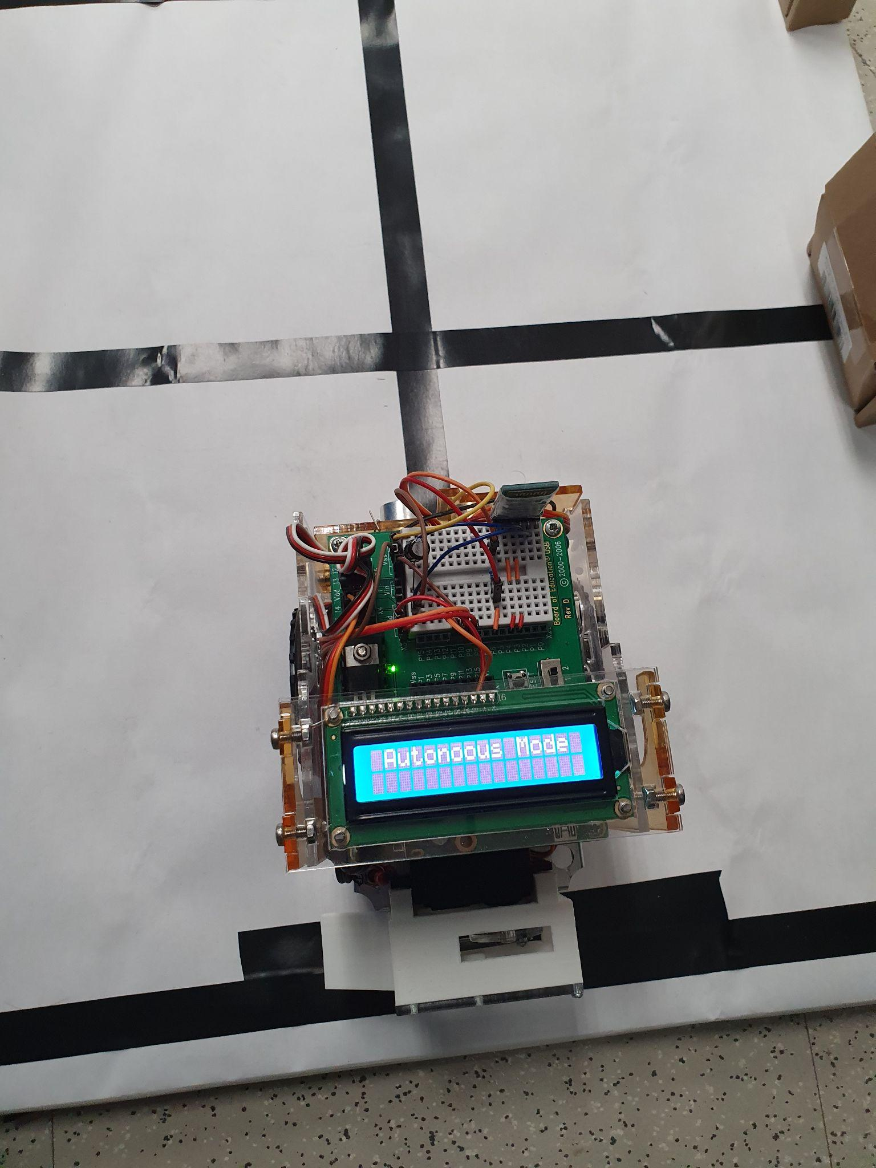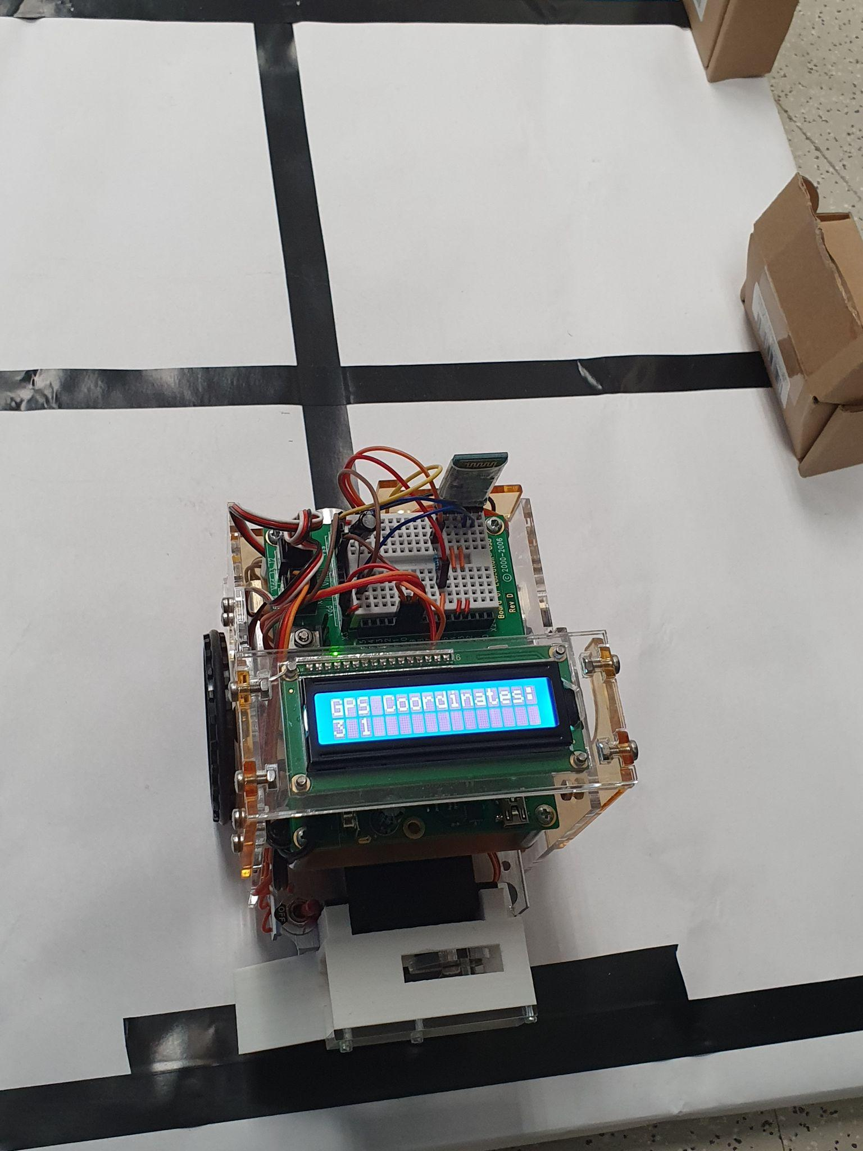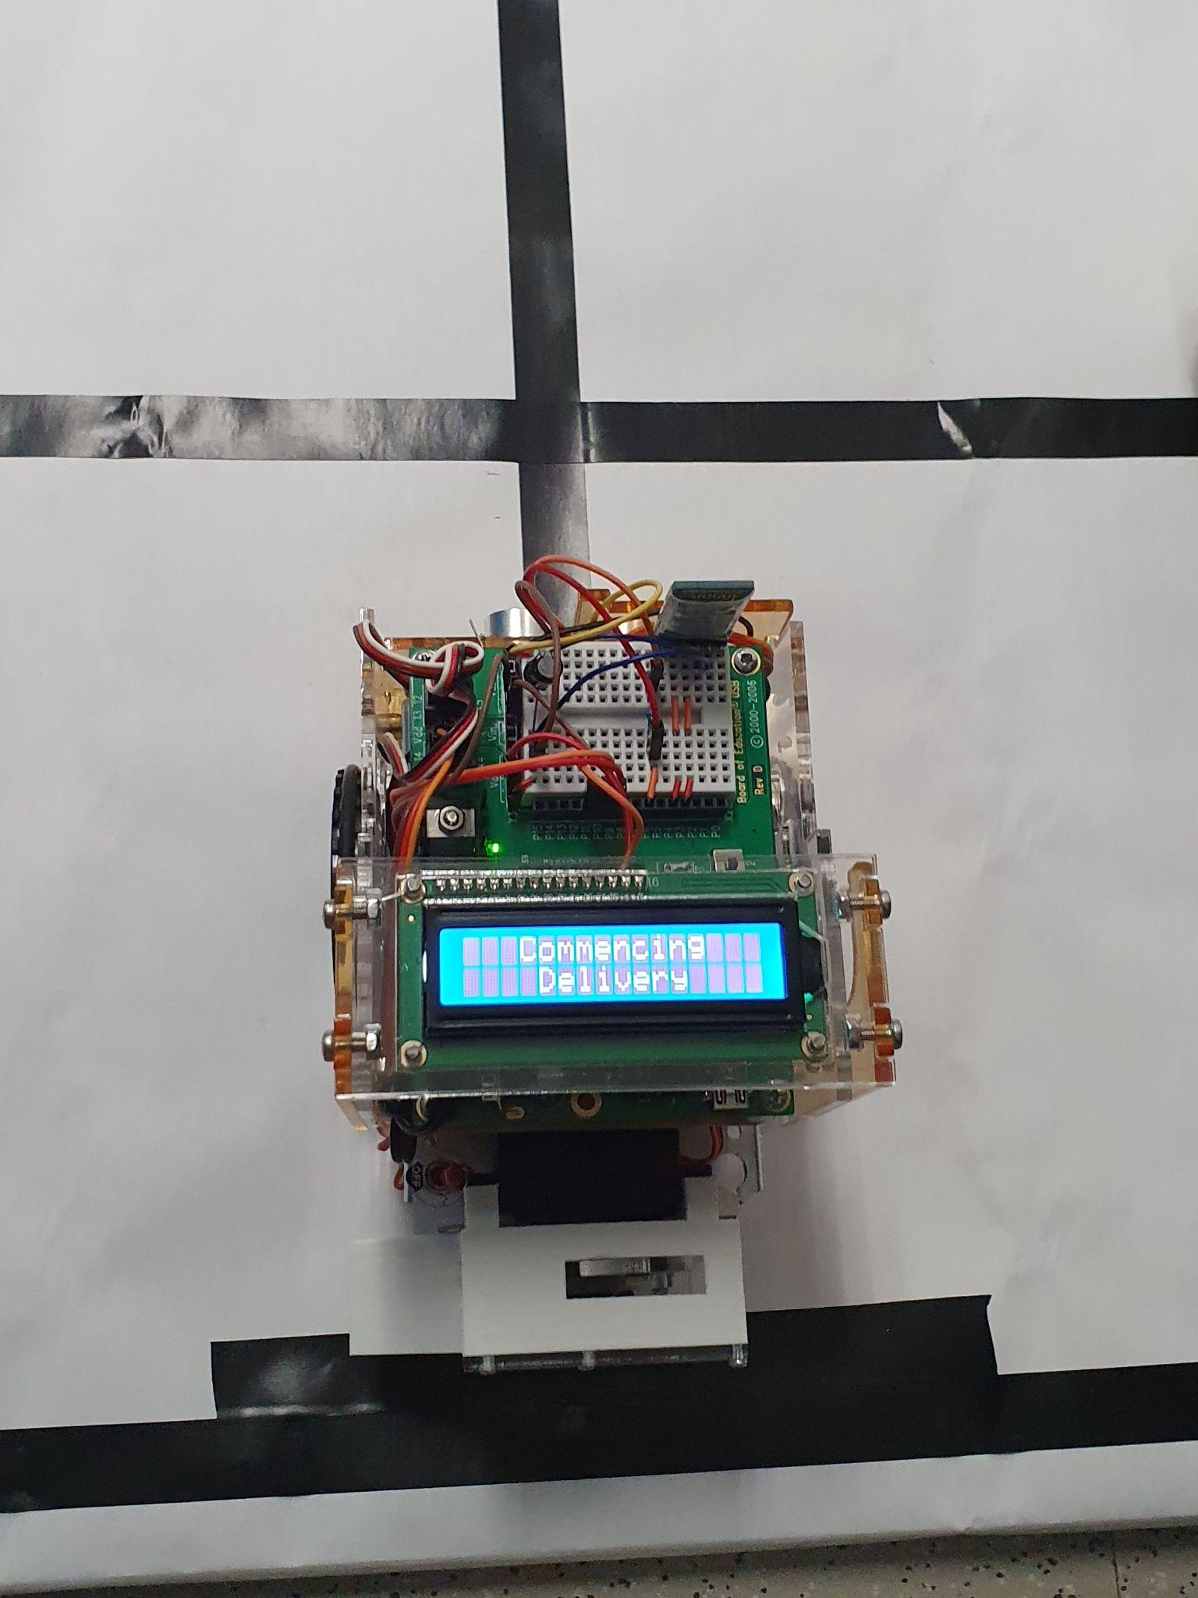

Alternatively, if autonomous mode is selected, the message shown in the first screen above is displayed. The Transbot then awaits GPS coordinates and the signal to begin the delivery. The message shown in the second figure is displayed when GPS coordinates are received and the message in the third figure is shown when the delivery signal is received. When the Transbot gets to the delivery lane, the message shown in the first image below is displayed. The device then turns 180 degrees, delivers the package, sounds the buzzer, displays the message in the second image below and then returns to the home base. If the home base is reached successfully, the third image below is displayed and the device returns to waiting for mode selection. Otherwise, if an obstacle is detected, the fourth image below is displayed and the device awaits the UI signal to switch to RC mode.

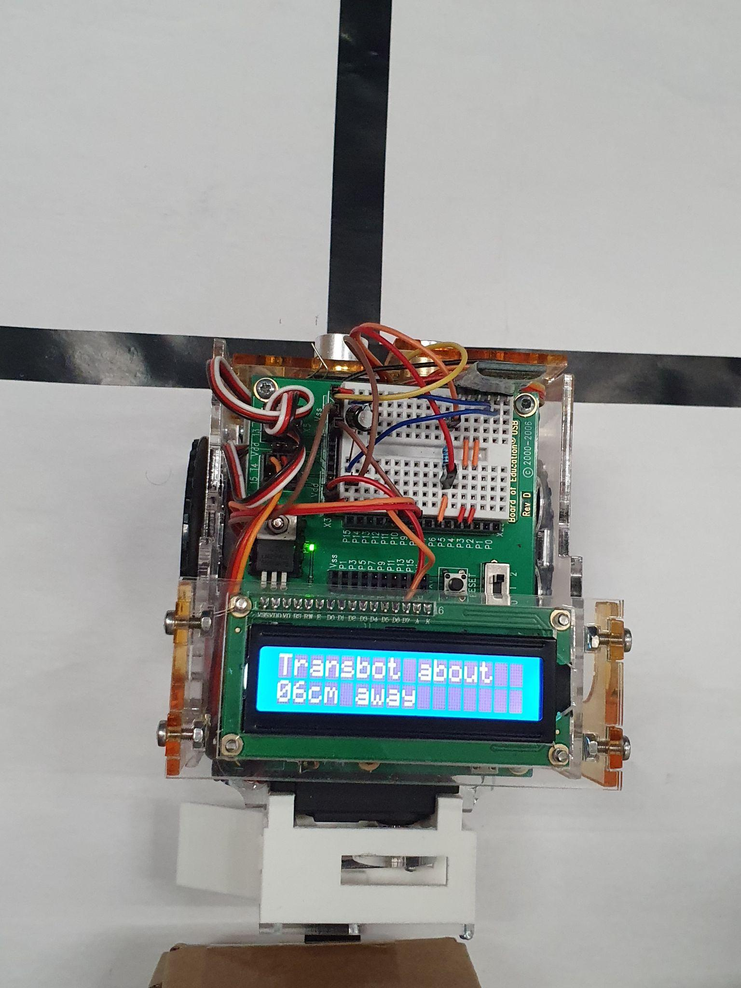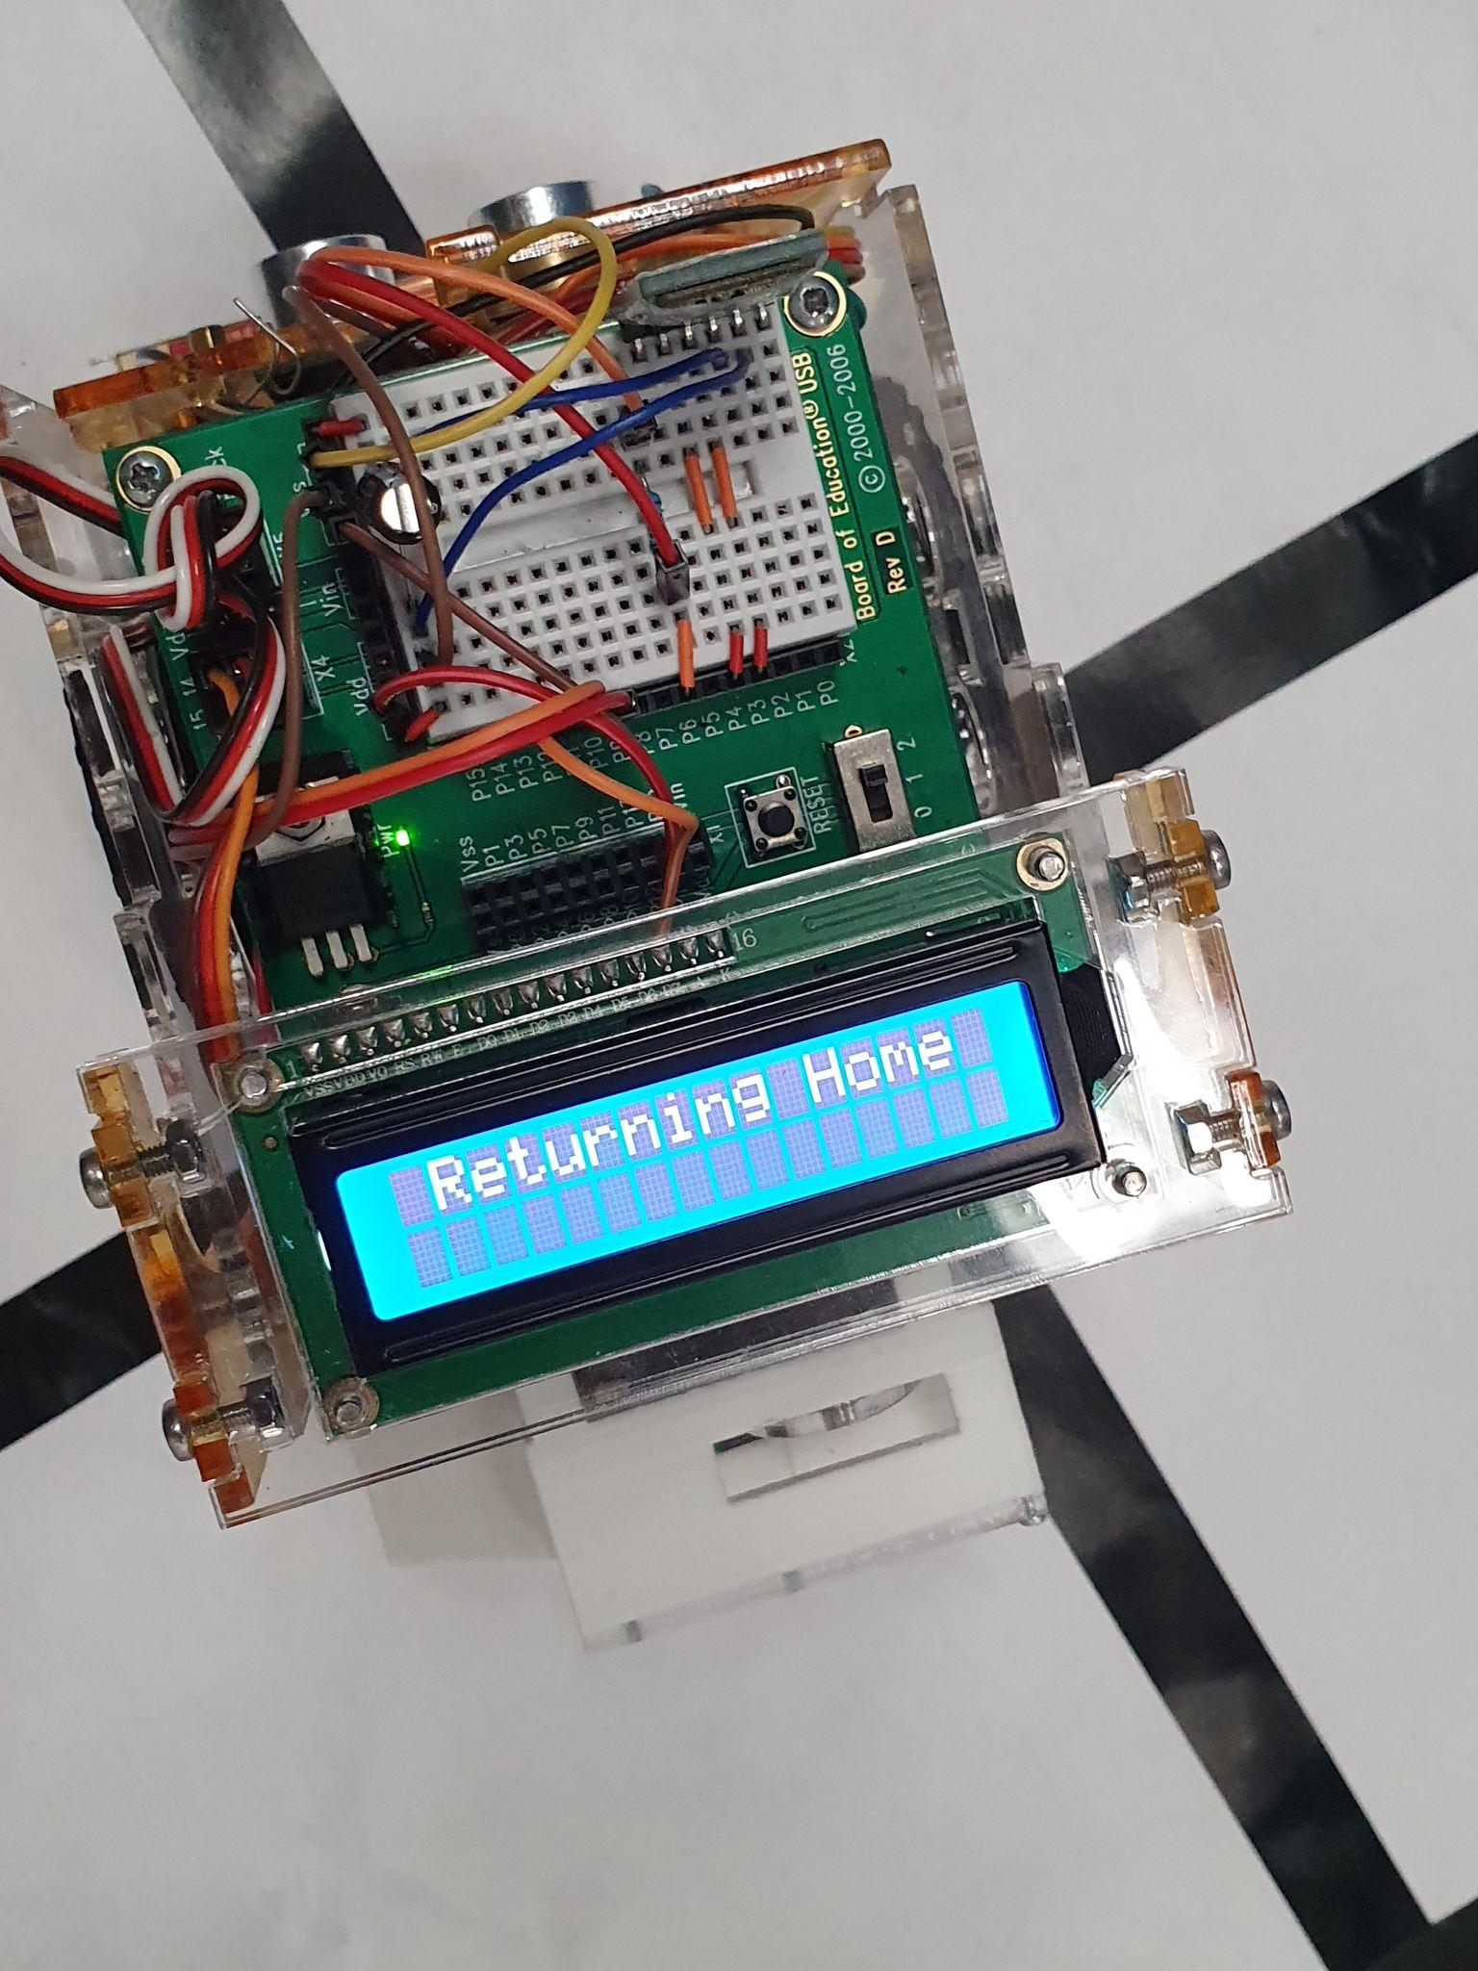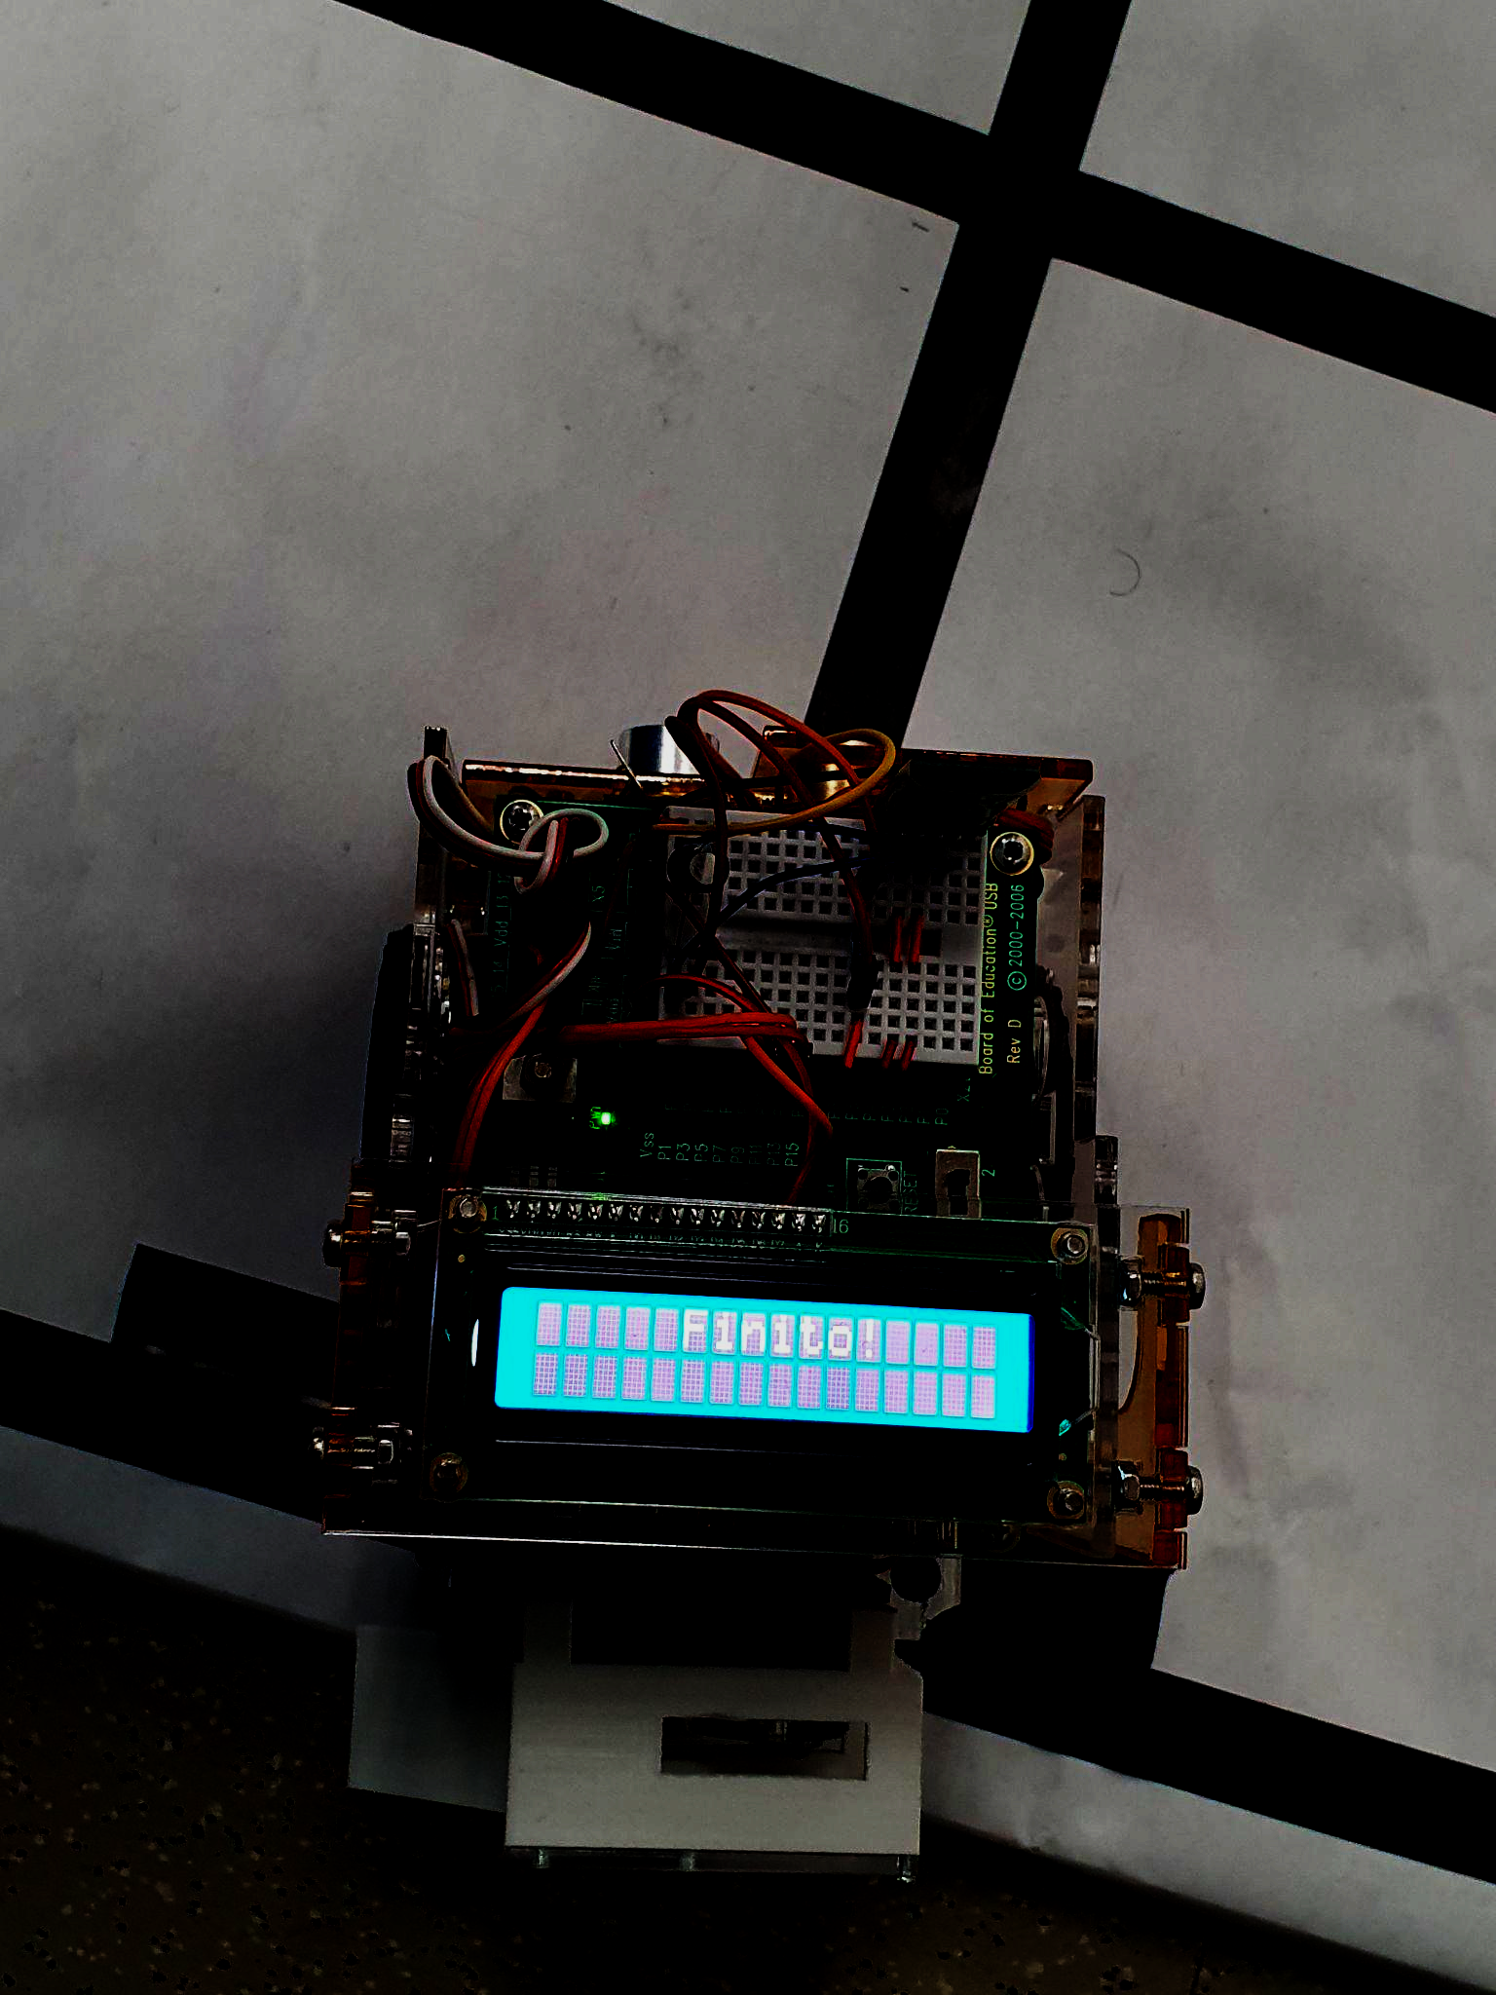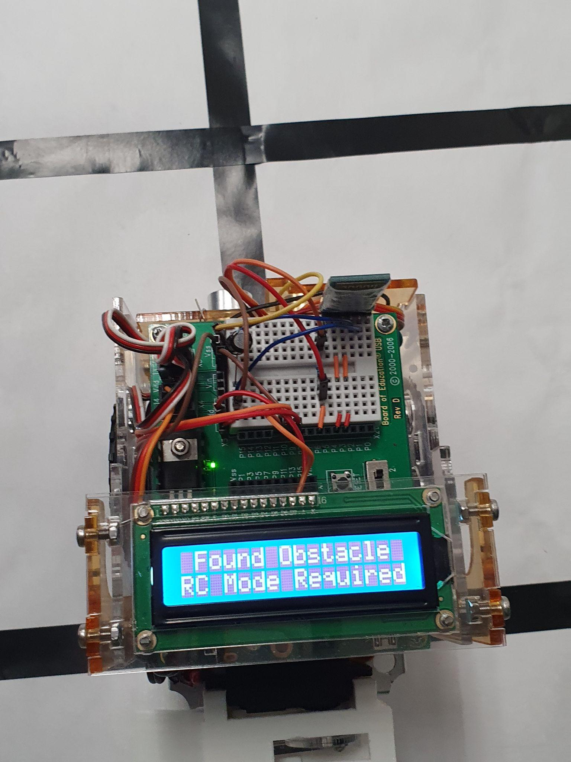

## MOBILE-APP-BASED USER INTERFACE *(TRANSBOT_UI)*

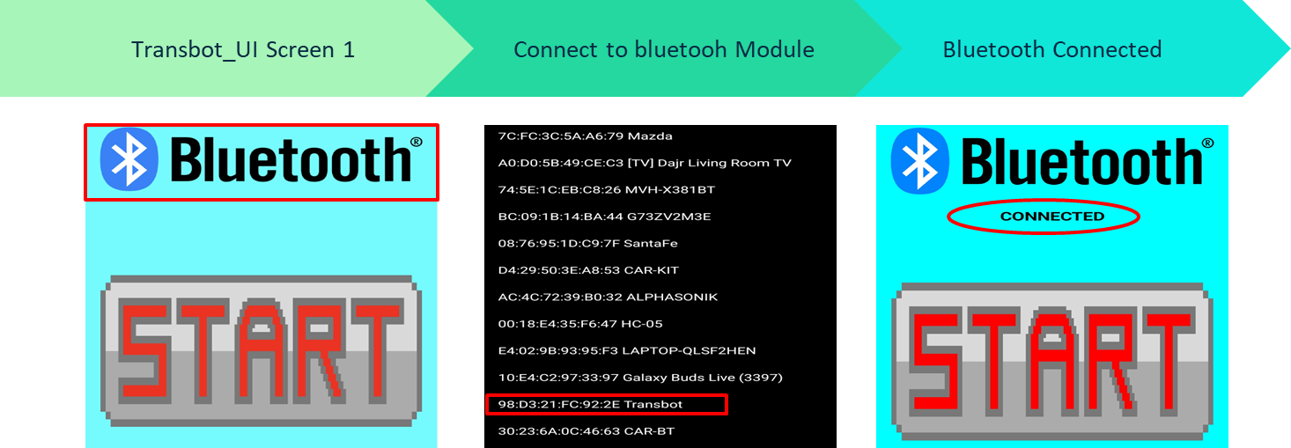

The Transbot UI allows the user to remotely control and monitor the Transbot while in operation. This mobile application was created using MIT App Inventor 2. The first screen above is displayed when the App is opened. After the Transbot is switched on, the user clicks the Bluetooth Listpicker button and the second screen above is displayed. From the list of paired bluetooth devices, the user selects the Transbot and the third screen above is displayed on connection.

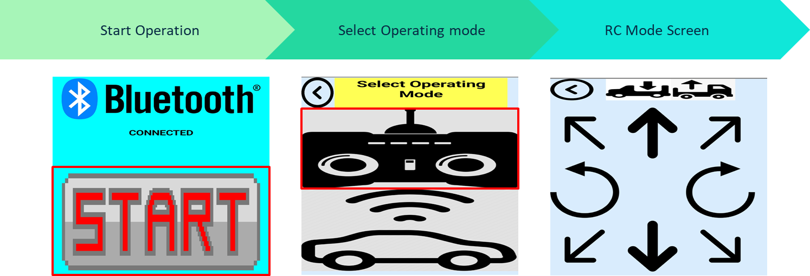

The user then clicks the start button, highlighted in the first image above. This initiates the calibration process on the Transbot while the mode selection screen is displayed on the App. The user should wait for the calibration process to finish and select the desired operating mode. If RC mode is selected, the screen shown in the third image above is displayed. The user can remotely control the Transbot by holding down the button corresponding to the desired movement. Two buttons are also included for actuating the delivery mechanism and a back button to return to the mode select screen.

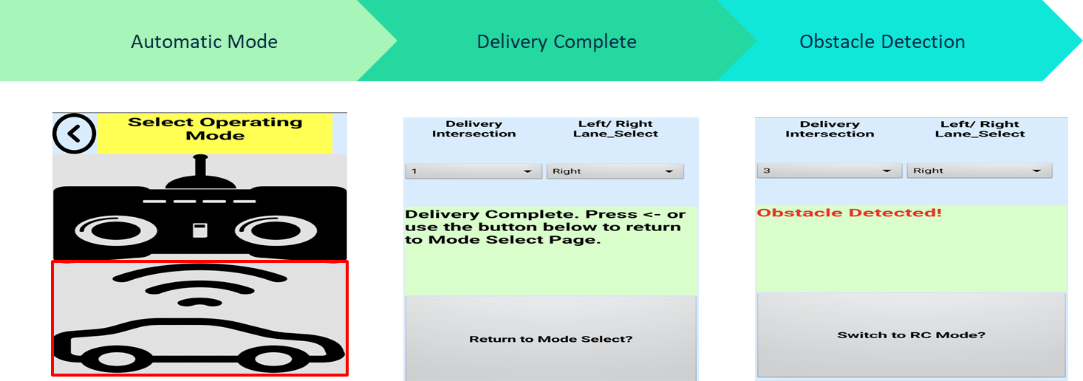

Alternatively, autonomous mode may be selected. The button to activate this mode is highlighted in the first image above. Upon entry into autonomous mode, the user inputs their desired delivery coordinates by choosing the delivery intersection (1-3) and either left/ right lanes (0/1). The user then hits a button to send the GPS coordinates which are then displayed on the Transbot’s onboard LCD. The delivery button is then clicked and the delivery commences. Upon successful completion of a delivery and return to home base, the screen in the second image above is displayed and the Transbot awaits the user to return to mode selection. However, if an obstacle is detected on the way to or from a delivery intersection, the screen shown in the third image above is displayed and the Transbot awaits the user to switch to RC Mode.

# COMPONENT CLASSIFICATION

| Component | Category(s) | Outline |
| --- | --- | --- |
| SPDT Toggle Switch | Shutdown | Enables the device operator to shutdown main battery power in the event of a malfunction of the Transbot. |
| Serial (UART) 1602 LCD and buzzer | User Interface | Communicates information about the Transbot’s operation to the operator. |
| (2) Continuous Servo Motors | Actuator | Enables movement of the Transbot which is controlled using feedback from ultrasonic and reflectance sensors |
| HC-05 Bluetooth Module | User Interface | Enables wireless communication between a remote user and the Transbot during remote-controlled operation |
| Arduino and Pololu Reflectance Sensor | Sensors (Analog) & Actuator Feedback | Analog sensor used for reading light levels to distinguish track from background. Determines whether servo movement is keeping the Transbot on track |
| Ultrasonic (Ping) Sensor | Sensors (Digital) | Relative Distance measurement |

# DEVICE MANUFACTURABILITY

## BILL OF MATERIALS

| Item | Quantity | Price |
| --- | --- | --- |
| Pololu Reflectance Sensor | 1 | $9.95 |
| Ultrasonic Sensor | 1 | $2.00 |
| Bluetooth Module | 1 | $8.71 |
| Parallax LCD | 1 | $34.95 |
| Positional Servo Motor | 1 | $7.50 |
| Arduino | 1 | $8.00 |
| Boe-Bot Robot Kit | 1 | $249.95 |
| Acrylic Sheet | 1 | $15.00 |
| PCB Blank | 1 | $1.00 |
| Miscellaneous | 1 | $20 |
|  | TOTAL PROTOTYPE COST | **$357.06** |

## COST ANALYSIS FOR MASS PRODUCTION

In order to successfully mass-produce this product, the cost of production must be low enough so that adequate profit can be obtained from the final sales price once other expenses and profit margins have been factored in. The demand for the product will also be impacted if the final sales price is too high. Currently, the cost of the prototype is too high to make mass production truly feasible. The main reason for this high cost is the Boe-Bot Robot Kit which accounts for 70% of the total prototype cost. By omitting the Robot Kit, much cheaper alternatives can be obtained. In terms of the microcontroller, the onboard Arduino Nano is more than capable of completely replacing the BS2. The Boe-Bot chassis can be easily replicated using sheet metal at a much lower price point or, alternatively, a plastic alternative may be created via plastic injection molding. Also, the mass production costs for several of the electronic components of the prototype could be greatly reduced by designing custom PCBs with the same functionality as these devices. The total unitary production cost could be reduced 7 fold by incorporating these techniques during mass production.

## 

## ADVANTAGE & DISADVANTAGE OF DESIGN

**Advantages**

* Easy to operate due to well designed UI
* Rechargeable batteries reduce device downtime
* Autonomous mode reduces labor-related-cost during operation
* RC Mode allows for a safe alternative to autonomous navigation in the event of device malfunction.
* Autonomous delivery reduces the spread of communicable diseases
* Accurate calibration process ensures proper consistent device operation

**Disadvantages**

* The Boe-Bot Kit accounts for 70% of total cost and is too expensive for such outdated and constrained technology.
* The BS2 does not have library support for most modern sensors like the Arduino does.
* The BS2 has insufficient memory capacity (only 2kB EEPROM and 32B variable space). The operations and functionality of the device was limited by the capabilities of the BS2. 99% of BS2 EEPROM was used as seen in the image below.

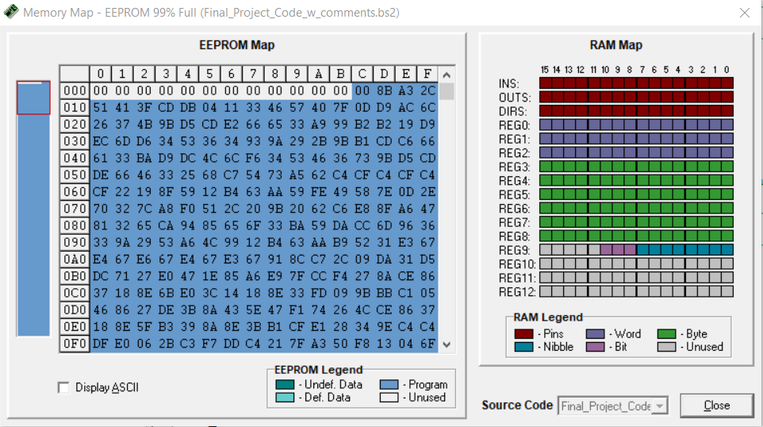

# CONCLUSION

The need for a device like the transbot cannot be over emphasized. Major emphasis has been put on its application in supporting delivery networks during a pandemic and how it indirectly could play a role in impeding the spread of communicable diseases. However, the transbot could find other applications in areas like the military, warehouse management, last mile logistics etc. The Transbot 1.0 design worked perfectly and satisfied all problem specifications. The transbot was able to interface with the Transbot_UI application using a bluetooth connection. It was able to deliver items to set GPS locations in automatic mode and was also controlled by an operator to deliver items to set locations in manual mode. The transbot was also able to detect obstacles in automatic mode, relay obstacle presence to the operator and give the operator the option to manually navigate past obstacles. Despite meeting all design specifications, some improvements can be made to increase the transbot’s functionality, efficiency and feasibility for real world application. Firstly, an Arduino can be used to replace the BS2 microcontroller. The arduino has more memory which would allow room for the coding of more complex operations. The Arduino is also a cheaper microcontroller which will reduce price for possible mass production. The arduino has larger current source(sink) values than the BS2 and it has a larger library and program compatibility with more advanced sensors in the market today. The Arduino also has cloud compatibility which could be a better option for remote control than Bluetooth.

# REFERENCES

* <https://www.pololu.com/docs/0J19/all>
* <https://www.creativebloq.com/news/bluetooth-logo>
* <https://www.pngall.com/start-button-png/download/77884>
* <https://www.pngkit.com/view/u2w7w7o0i1o0y3w7_collection-of-free-droned-clipart-rc-controller-drone/>
* <https://www.iconfinder.com/icons/1565085/autonomous_car_driverless_driving_mobile_self_driving_car_icon>
* <https://www.clipartmax.com/middle/m2i8b1K9K9m2H7d3_up-arrow-svg-png-icon-free-download-up-arrow-png-icon/>
* <https://commons.wikimedia.org/wiki/File:Feather-arrows-arrow-up-left.svg>
* <https://commons.wikimedia.org/wiki/File:Clockwise_Arrow.svg>
* <https://commons.wikimedia.org/wiki/File:Counterclockwise_Arrow.svg>
* <https://www.parallax.com/product/basic-stamp-syntax-and-reference-manual-v2-2/>
* <https://www.parallax.com/package/parallax-serial-lcd-with-piezospeaker-product-guide/>
* <https://forums.parallax.com/discussion/comment/1301893/#Comment_1301893>
* <https://docs.arduino.cc/hardware/nano>
* <http://ai2.appinventor.mit.edu/>

# APPENDIX

## BASIC STAMP 2 CODE

' {$STAMP BS2}

' {$PBASIC 2.5}

'------------------------------------------------------------------------------------------------

' PINS

'------------------------------------------------------------------------------------------------

BT_RX PIN 4 'Set bluetooth(BT) receiving pin to 4 on BS2

BT_TX PIN 3 'Set bluetooth transmitting pin to 3 on BS2

FRT_ULTRA PIN 6 'Set front ultrasonic pin to 6 on BS2

ARD_RX PIN 10 'Set Arduino receiving pin to 10 on BS2

ARD_TX PIN 9 'Set Arduino transmit pin to 9 on BS2

LCD_RX PIN 11 'Set LCD receiving pin to 11 on BS2

RGT_SERVO PIN 13 'Set right servo motor pin to 13 on BS2

LFT_SERVO PIN 12 'Set left servo motor pin to 12 on BS2

MEC_SERVO PIN 14 'Set MG995 Servo Motor (Delivery Mechanism) pin to 14 on BS2

'------------------------------------------------------------------------------------------------

'CONSTANTS

'------------------------------------------------------------------------------------------------

'RC Commands from App UI

releaseSig CON 250 'Trigger to Return to Mode Selection

F_Command CON 10 'Move transbot forward

R_Command CON 20 'Move transbot backward

TL_Command CON 30 'Turn transbot left

TR_Command CON 40 'Turn transbot right

SL_Command CON 50 'Spin transbot left

SR_Command CON 60 'Spin transbot right

RL_Command CON 70 'Reverse transbot left

RR_Command CON 80 'Reverse transbot right

Load_Command CON 90 'Set transbot delivery mechanism to load position

Del_Command CON 100 'Command for transbot to deliver item

Stop_Command CON 110 'Stop transbot

'Required Operating Constants

MechLoadPos CON 1150 'Servo position for loading delivery mechanism

MechDeliverPos CON 800 'Servo position for delivering package from delivery mechanism

CmConstant CON 2260 'Centimeter constant of ultrasonic sensor

CSpeed CON 775 'Clockwise speed of servo motors

ASpeed CON 725 'Anticlockwise speed of servo motors

StopSpeed CON 750 'Constant to stop servo motors

InterThresh CON 240 'Intersection reflectance threshold of Pololu sensor

LeftThresh CON 140 'Position threshold to turn left to recenter the Transbot

RightThresh CON 110 'Position threshold to turn right to recenter the Transbot

DistThresh CON 8 'Distance threshold for obstaclel detection and delivery to houses

'Interfacing Constants

ArdStx CON 396 ' 396:2400-8N1, 84:9600-8N1 'Baud rate of serial connection between 'Transbot and Arduino

LCDStx CON 84 ' 396:2400-8N1, 84:9600-8N1 'Baud rate of serial connection between 'Transbot and LCD

BTStx CON 396 ' 396:2400-8N1, 84:9600-8N1 'Baud rate of serial connection between 'Transbot and Bluetooth

'------------------------------------------------------------------------------------------------

'VARIABLLES

'------------------------------------------------------------------------------------------------

InterCheck VAR Bit 'Intersection Check: Gets set to 1 if interection detected

ObstacleCheck VAR Bit 'Obstacle Check: Gets set to 1 if obstacle detected

GPSB VAR Bit 'Gets set to 0 for left lanes and 1 for right lanes

InterCount VAR Nib 'Counts the number of intersections that have been encountered

GPSA VAR Nib 'Gets set to 1, 2 or 3 to indicate the intersection where delivery is to take 'place

Counts VAR Byte 'for loop counter

moveCount VAR Byte 'Stores the number of for-loop iterations the motion sequences(eg 'Move_Forward) should run for

arduino_R VAR Byte 'stores the value returned by arduino during calibration

sensorVals VAR Byte(9) 'store readings of Pololu position estimate and 8 reflectance sensor 'readings

cmDistance VAR Word ' store distant measurement of Ultrasonic sensor

time VAR Word 'store sound travel time of ultrasonic sensor

bluetooth_R VAR Word 'Stores values returned from Bluetooth module when communicating 'with App UI

moveCount = 50 'Initialize moveCount to 50 iterations

InterCount = 0 'Initialized to 0

GPSA = 1 'Delivery Intersection. Default = 1

GPSB = 0 '0: Turn Left, 1:Turn Right. Default = Left(0)

'------------------------------------------------------------------------------------------------

'CODE

'------------------------------------------------------------------------------------------------

Initialization: 'Setup Sequence ran when Transbot boots up

PAUSE 1000 ' Delay to allow proper boot-up of all system peripherals

'LCD Welcome Message

SEROUT LCD_RX,LCDStx,[22,12,17,220]'22: Turns on LCD, 12: Clears screen, 17: Turns on 'Backlight, 220: Play A note

PAUSE 5

SEROUT LCD_RX, LCDStx, [" Welcome! "]

'Stop Lft & Rgt Servos

GOSUB Stop_Motors

'Move Delivery mechanism to loading positon

GOSUB Mech_Load

'Establish BT Connection

PAUSE 1000

SEROUT LCD_RX,LCDStx,[22,12,17]'22: Turns on LCD, 12: Clears screen, 17: Turns on 'Backlight

PAUSE 5

SEROUT LCD_RX, LCDStx, ["Connecting to BT......"]

DO UNTIL(bluetooth_R = 250)'Wait for Start Signal from BT module (UI now on Mode select 'pg)

GOSUB BT_Rec

LOOP

PAUSE 1000

'Calibrate Arduino

SEROUT LCD_RX,LCDStx,[22,12,17,224,226]'22: Turns on LCD, 12: Clears screen, 17: 'Turns on Backlight

PAUSE 5

SEROUT LCD_RX, LCDStx, [" Calibrating Sensors....."]

GOSUB Ard_Calib

PAUSE 1000

'Go to mode select code block

GOTO Mode_Select

Mode_Select: 'Mode Selection Routine. Remains here until a 6(RC Mode) or 7(Autonomous 'Mode) is received from the App UI

SEROUT LCD_RX,LCDStx,[22,12,17]'22: Turns on LCD, 12: Clears screen, 17: Turns on Backlight

PAUSE 5

SEROUT LCD_RX, LCDStx, [" Select Mode of Operation"]

GOSUB BT_Rec

IF(bluetooth_R = 6)THEN

SEROUT LCD_RX,LCDStx,[22,12,17]'22: Turns on LCD, 12: Clears screen, 17: Turns on Backlight

PAUSE 5

SEROUT LCD_RX, LCDStx, [" RC Mode "]

GOSUB RC_Mode

ELSEIF(bluetooth_R = 7)THEN

SEROUT LCD_RX,LCDStx,[22,12,17]'22: Turns on LCD, 12: Clears screen, 17: Turns on Backlight

PAUSE 5

SEROUT LCD_RX, LCDStx, [" Autonoous Mode "]

GOSUB Delivery_Sequence

ENDIF

GOTO Mode_Select

'GOTO Stopper

Ard_Calib: 'Calibrate sequence - Transbot sweeps from 90 degrees left to 90 degrees right and 'back to center while Arduino calibrates reflectance sensors

SEROUT ARD_RX,ArdStx,["c"] 'Send "c" to arduino to start calibration process

GOSUB ARD_Rec 'read calibration values

moveCount = 45

GOSUB Spin_Left 'Spin transbot left

moveCount = 75

GOSUB Spin_Right 'Spin transbot right

moveCount = 30

GOSUB Spin_Left 'Spin transbot left

SEROUT ARD_RX,ArdStx,["d"] 'Send "d" to arduino to end calibration process

GOSUB ARD_Rec 'read value from arduino

RETURN

RC_Mode: 'Sequence for RC operation of the transbot. Polls BT module until a command signal 'is received or a release signal is received which returns to the Mode Select Routine

SEROUT BT_RX,BTStx,["s"]

GOSUB BT_Rec 'recieve value from the app

DO WHILE(bluetooth_R <> releaseSig)'run sequence until the value received is equal to the 'mode selection value

SELECT bluetooth_R ' compare the value recieved from the app with RC operation constant 'then execute command

CASE F_Command

moveCount = 2

GOSUB Move_Forward

CASE R_Command

moveCount = 2

GOSUB Move_Backward

CASE TL_Command

moveCount = 2

GOSUB Turn_Left

CASE TR_Command

moveCount = 2

GOSUB Turn_Right

CASE SL_Command

moveCount = 2

GOSUB Spin_Left

CASE SR_Command

moveCount = 2

GOSUB Spin_Right

CASE RL_Command

moveCount = 2

GOSUB Rev_Left

CASE RR_Command

moveCount = 2

GOSUB Rev_Right

CASE Load_Command

GOSUB Mech_Load

CASE Del_Command

GOSUB Mech_Deliver

CASE Stop_Command

GOSUB Stop_Motors

ENDSELECT

'Ask for next command

SEROUT BT_RX,BTStx,["s"]

GOSUB BT_Rec

LOOP

RETURN

Mech_Load: 'Sequence to Move Delivery Mechanism Servo to Load Position

FOR Counts = 1 TO 20

PULSOUT MEC_SERVO, MechLoadPos

PAUSE 50

NEXT

RETURN

Mech_Deliver: 'Sequence to Move Delivery Mechanism Servo to Delivery Position

FOR Counts = 1 TO 20

PULSOUT MEC_SERVO, MechDeliverPos

PAUSE 50

NEXT

Stop_Motors:'Sequence to Stop Transbot Motors

FOR Counts = 1 TO moveCount

PULSOUT LFT_SERVO, StopSpeed

PULSOUT RGT_SERVO, StopSpeed

PAUSE 20

NEXT

RETURN

Spin_Right:'Sequence to Spin Transbot Right(Clockwise)

FOR Counts = 1 TO moveCount

PULSOUT LFT_SERVO, CSpeed

PULSOUT RGT_SERVO, CSpeed

PAUSE 20

NEXT

RETURN

Spin_Left:'Sequence to Spin Transbot Left(Counter-Clockwise)

FOR Counts = 1 TO moveCount

PULSOUT LFT_SERVO, ASpeed

PULSOUT RGT_SERVO, ASpeed

PAUSE 20

NEXT

RETURN

Turn_Left:'Sequence to Turn Transbot Left while moving forward

FOR Counts = 1 TO moveCount

PULSOUT LFT_SERVO, StopSpeed

PULSOUT RGT_SERVO, ASpeed

PAUSE 20

NEXT

RETURN

Turn_Right: 'Sequence to Turn Transbot Right while moving forward

FOR Counts = 1 TO moveCount

PULSOUT LFT_SERVO, CSpeed

PULSOUT RGT_SERVO, StopSpeed

PAUSE 20

NEXT

RETURN

Rev_Left: 'Sequence to Turn Transbot Left while moving backward

FOR Counts = 1 TO moveCount

PULSOUT LFT_SERVO, StopSpeed

PULSOUT RGT_SERVO, CSpeed

PAUSE 20

NEXT

RETURN

Rev_Right: 'Sequence to Turn Transbot Right while moving backward

FOR Counts = 1 TO moveCount

PULSOUT LFT_SERVO, ASpeed

PULSOUT RGT_SERVO, StopSpeed

PAUSE 20

NEXT

RETURN

Move_Backward:'Sequence to Move Transbot Backward

FOR Counts = 1 TO moveCount

PULSOUT LFT_SERVO, ASpeed

PULSOUT RGT_SERVO, CSpeed

PAUSE 20

NEXT

RETURN

Move_Forward:'Sequence to Move Transbot Forward

FOR Counts = 1 TO moveCount

PULSOUT LFT_SERVO, CSpeed

PULSOUT RGT_SERVO, ASpeed

PAUSE 20

NEXT

RETURN

BT_Rec:'Routine to receive commands from BT module

SERIN BT_TX,BTStx,[DEC bluetooth_R]

'DEBUG DEC bluetooth_R,CR

SEROUT LCD_RX,LCDStx,[22,12,17]'22: Turns on LCD, 12: Clears screen, 17: Turns on Backlight

PAUSE 5

SEROUT LCD_RX, LCDStx, ["Value from user: ",DEC bluetooth_R]

RETURN

Ard_Rec: 'Sequence to receive values returned from Arduino during calibration sequence (90: 'Calibration Commenced, 95: Calibration Finished)

SERIN ARD_TX,ArdStx,[DEC arduino_R] 'collect value

'DEBUG DEC arduino_R,CR 'Display on debug screen

'SEROUT LCD_RX,LCDStx,[22,12,17]'22: Turns on LCD, 12: Clears screen, 17: Turns on Backlight

'PAUSE 5

'SEROUT LCD_RX, LCDStx, ["Arduino Value: ",DEC arduino_R] 'send arduino value to lcd screen

RETURN

Read_Pos:'Sequence to Receive Position Estimate and (8) Reflectance Values from Arduino

SEROUT ARD_RX,ArdStx,["r"]'instruct adruino to read the values from the pulolo sensor

'DEBUG CRSRXY ,0,2

InterCheck = 1

FOR Counts = 0 TO 8

SERIN ARD_TX,ArdStx,[DEC sensorVals(Counts)]'collects position from audrino

IF(Counts <> 0) THEN ' check if we are at an intersection leave InterCheck set to 1 else set InterCheck to 0

'DEBUG DEC3 sensorVals(Counts)," "

IF(sensorVals(Counts)< InterThresh) THEN

InterCheck = 0

ENDIF

ENDIF

NEXT

'DEBUG CR,"Line Position: ", DEC3 sensorVals(0)," At Intersection?:",DEC1 InterCheck,CR

RETURN

Line_Follow:'Routine to Follow Line by keeping the Position Estimate received from Arduino 'between the Left and Right Thresholds by turning when necessary

GOSUB Read_Pos ' read position of the lines

IF(sensorVals(0)>LeftThresh)THEN ' if the position of line is greater than the left threshold 'turn left to placetransbot at center of the line

DO WHILE(sensorVals(0)>LeftThresh)

moveCount = 1

GOSUB Spin_Left

'GOSUB Stop_Motors

GOSUB Read_Pos

LOOP

ENDIF

IF(sensorVals(0)<RightThresh)THEN

DO WHILE(sensorVals(0)<RightThresh)' if the position of line is greater than the left threshold 'turn left to placetransbot at center of the line

moveCount = 1

GOSUB Spin_Right

'GOSUB Stop_Motors

GOSUB Read_Pos

LOOP

ENDIF

moveCount = 2

GOSUB Move_Forward

'GOSUB Stop_Motors

RETURN

LT_Inter: ' Sequence to turn left at an intersection

moveCount = 60

GOSUB Turn_Left

GOSUB Read_Pos

DO WHILE(sensorVals(0)>125)

moveCount = 1

GOSUB Turn_Left

GOSUB Read_Pos

LOOP

RETURN

RT_Inter:'Sequence to turn right at an intersection

moveCount = 60

GOSUB Turn_Right

GOSUB Read_Pos

DO WHILE(sensorVals(0)<125)

moveCount = 1

GOSUB Turn_Right

GOSUB Read_Pos

LOOP

RETURN

Turn_180:'Sequence to turn Transbot 180 degrees on track

moveCount = 70

GOSUB Spin_Right

GOSUB Read_Pos

DO WHILE(sensorVals(0)<125)

moveCount = 1

GOSUB Turn_Right

GOSUB Read_Pos

LOOP

RETURN

DistanceMeasurement:'Sequence to receive obstacle distance values from Ultrasonic sensor and 'check if we are within the Obstacle Detection Distance Threshold

PULSOUT FRT_ULTRA, 5 ' just measures the distance to the delivery locaton

PULSIN FRT_ULTRA, 1, time

cmDistance = CmConstant ** time

ObstacleCheck = 0

IF(cmDistance < DistThresh) THEN

ObstacleCheck = 1

ENDIF

'DEBUG CRSRXY ,0,4, DEC3 cmDistance, " cm Obstacle Detected?:",DEC1 ObstacleCheck,CR

RETURN

Delivery_Sequence:'Sequence to handle autonomous operation of Transbot

InterCount = 0 'Reset InterCount (Device should be at Home position when autonomous 'delivery commences

GOSUB Mech_Load'Ensure boebot is in loading position

DO WHILE(bluetooth_R <> 5)'Loop to manage transfer of GPS Coordinates from App UI 'while waiting for Commence Signal(5) from UI

SERIN BT_TX,BTStx,[DEC bluetooth_R]

IF(bluetooth_R <= 3)THEN

GPSA = bluetooth_R

SERIN BT_TX,BTStx,[DEC bluetooth_R]

GPSB = bluetooth_R

SEROUT LCD_RX,LCDStx,[22,12,17]

PAUSE 5

SEROUT LCD_RX, LCDStx, ["GPS Coordinates:",DEC1 GPSA," ",DEC1 GPSB]

ELSEIF(bluetooth_R = 250)THEN

GOTO Mode_Select

ENDIF

LOOP

SEROUT LCD_RX,LCDStx,[22,12,17,226,225,224]

PAUSE 5

SEROUT LCD_RX, LCDStx, [" Commencing Delivery"]

PAUSE 1000

DO WHILE(InterCount < GPSA)'Loop to line follow while checking for obstacles and 'intersections until we get to the delivery intersection

GOSUB Line_Follow

GOSUB Obstacle_Sequence

IF(InterCheck = 1) THEN

InterCount = InterCount+1

IF(InterCount < GPSA) THEN

moveCount = 15

GOSUB Move_Forward

ENDIF

ENDIF

LOOP

IF(GPSB = 0) THEN'Turn left/ right depnding on GPSB value

GOSUB LT_Inter

ELSE

GOSUB RT_Inter

ENDIF

DO WHILE(ObstacleCheck = 0)'Line follow and ceck distance until the Transbot is close 'enough to the house

GOSUB Line_Follow

GOSUB DistanceMeasurement

SEROUT LCD_RX,LCDStx,[22,12,17]

PAUSE 5

SEROUT LCD_RX, LCDStx, ["Transbot about ",DEC2 cmDistance,"cm away"]

LOOP

GOSUB Turn_180'Turn the Transbot 180 degrees

GOSUB Mech_Deliver'Deliver the package

SEROUT LCD_RX,LCDStx,[227,228,230]

PAUSE 1000

GOSUB Mech_Load' Reset the delivery mechanism

PAUSE 5

SEROUT LCD_RX,LCDStx,[22,12,17,224]

PAUSE 5

SEROUT LCD_RX, LCDStx, [" Returning Home "]

DO WHILE(InterCheck = 0)'Return to Main track

GOSUB Line_Follow

LOOP

IF(GPSB = 0) THEN 'Turn towards Home Base

GOSUB RT_Inter

ELSE

GOSUB LT_Inter

ENDIF

DO WHILE(InterCount > 0)'Return to Home Base by line following and checking for 'intersections and obstacles

GOSUB Line_Follow

GOSUB Obstacle_Sequence

IF(InterCheck = 1) THEN

InterCount = InterCount-1

IF(InterCount > 0) THEN

moveCount = 15

GOSUB Move_Forward

ENDIF

ENDIF

LOOP

SEROUT LCD_RX,LCDStx,[22,12,17,227,228,230,228,227]

PAUSE 5

SEROUT LCD_RX, LCDStx, [" Finito! "]

GOSUB Turn_180'Turn around

SEROUT BT_RX,BTStx,["d"]'Send done signal to App UI

RETURN'Return to Mode Select

Obstacle_Sequence:'Sequence to handle obstacle detection by displaying a message on the LCD, 'sounding the buzzer, signalling the UI and returning to Mode Selection to allow for the switch 'to RC Mode

GOSUB DistanceMeasurement

IF(ObstacleCheck = 1) THEN

SEROUT LCD_RX,LCDStx,[22,12,17,226,226,226]

PAUSE 5

SEROUT LCD_RX, LCDStx, [" Found Obstacle RC Mode Required"]

PAUSE 4000

SEROUT BT_RX,BTStx,["o"]'Send obstacle detected signal to App UI

PAUSE 1000

GOTO Mode_Select

ENDIF

RETURN

## ARDUINO CODE

#include <QTRSensors.h> // Pololu's Library for the Reflective sensor

#include <SoftwareSerial.h>

//Pololu ULT8 Sensor Pins

const uint8_t refLED=10;

const uint8_t ref1=9;

const uint8_t ref2=8;

const uint8_t ref3=7;

const uint8_t ref4=6;

const uint8_t ref5=5;

const uint8_t ref6=4;

const uint8_t ref7=3;

const uint8_t ref8=2;

const uint8_t SensorCount = 8; //number of sensor pins

uint16_t sensorValues[SensorCount]; //Array to store sensor values

uint16_t pos;

char com;

//UART Pins

const int ARD_RX = 11;

const int ARD_TX = 12;

QTRSensors qtr;

SoftwareSerial prop(ARD_RX, ARD_TX); // RX, TX

void setup() {

delay(50);// (Not necessary but...) wait for a bit of time to ensure everything has booted up

qtr.setTypeRC(); // or setTypeAnalog() Set QTR Sensor for Digital mode

qtr.setSensorPins((const uint8_t[]){ref1, ref2, ref3, ref4, ref5, ref6, ref7, ref8}, SensorCount); // Tells the QTR Library the pins connected to the QTR Sensor and //the number of pins

qtr.setEmitterPin(refLED);

prop.begin(2400);

while(com!='c'){

while(!prop.available()) {

}

com=prop.read();

}

////////////////////////////Calibration/////////////////////////////////////

calibration();

}

void loop() {

while(!prop.available()){

}

com=prop.read();

if(com=='c'){

calibration();

}

else if(com=='r'){

pos=qtr.readLineBlack(sensorValues);

delay(10);

//prop.print(pos);

prop.print(byte(pos/28.0));//for BS2

delay(10);

for(int i=0;i<SensorCount;i++){

prop.print('\t');

delay(10);

//prop.print(sensorValues[i]);

prop.print(byte(sensorValues[i]/4));//for BS2

delay(10);

}

prop.print('\n');

}

}

void calibration(){

delay(20);

prop.print(90);

prop.print('\n');

while(com!='d'){

if(prop.available()){

com=prop.read();

if(com=='d'){

break;

}

}

qtr.calibrate();

if(prop.available()){

com=prop.read();

if(com=='d'){

break;

}

}

delay(10);

}

delay(20);

prop.print(95);

prop.print('\n');

delay(20);

}

## LINK TO DEMO VIDEO

<https://drive.google.com/file/d/1IJGcF0lD6umzCpYInCI9JzB4g6B59FJ8/view?usp=sharing>

